
FAST Application Software

L_ICIP_CommunicationInterface Function Blocks
Automation Building Blocks
_ _ _ _ _ _ _ _ _ _ _ _ _ _ _ _ _ _ _ _ _ _ _ _ _ _ _ _ _ _
Reference Manual EN
●
This manual applies to the Automation Building Blocks L_ICIP_COMMUNICATIONINTERFACE Function Blocks.

Copyright
© 2025 Lenze SE. All rights reserved.

Imprint
Lenze SE
Hans-Lenze-Strasse 1, D-31855 Aerzen, Germany
Phone: +49 (0)5154 / 82-0
Fax: +49 (0)5154 / 82-2111
E-Mail: Lenze@Lenze.de

Copyright information
All texts, photos and graphics contained in this documentation are subject to copyright
protection. No part of this documentation may be copied or made available to third parties
without the explicit written approval of Lenze SE.

Liability
All information given in this documentation has been carefully selected and tested for
compliance with the hardware and software described. Nevertheless, discrepancies
cannot be ruled out. We do not accept any responsibility or liability for any damage that
may occur. Required correction will be included in updates of this documentation.

Trademarks
Microsoft, Windows and Windows NT are registered trademarks or trademarks of the Microsoft Corporation in the USA and/or other countries.
Adobe and Reader are registered trademarks or trademarks of Adobe System Incorporated in the USA and/or other countries.
Any additional trade names given in this documentation are trademarks of their corresponding owners.

Contents

1 Function Blocks 2-1
1.1 Document History 2-1
1.2 About Automation Building Blocks 2-1
1.3 Conventions used 2-2
1.4 System Requirements 2-3
2 Function Blocks 2-4
2.1 Function Block L_ICIP_PROFIBUS_Base 2-6
2.1.1 Configuration Mode Selection (GSD/GSE Configuration) 2-6
2.1.2 Parameter Handling 2-7
2.1.3 Incompatibility List 2-12
2.1.4 Interface 2-13
2.1.5 Task Information 2-13
2.1.6 Inputs and Outputs 2-13
2.1.7 Inputs 2-13
2.1.8 Outputs 2-16
2.2 Function Block L_ICIP_PROFIBUS_In 2-19
2.2.1 Process Data (PZD) 2-20
2.2.2 Drivecom State Machine 2-21
2.2.3 Incompatibility List 2-22
2.2.4 Interface 2-23
2.2.5 Task Information 2-23
2.2.6 Inputs and Outputs 2-23
2.2.7 Inputs 2-23
2.2.8 Outputs 2-23
2.3 Function Block L_ICIP_PROFIBUS_Out 2-27
2.3.1 Process Data (PZD) 2-28
2.3.2 Drivecom State Machine 2-30
2.3.3 Incompatibility List 2-31
2.3.4 Interface 2-32
2.3.5 Task Information 2-32
2.3.6 Inputs and Outputs 2-32
2.3.7 Inputs 2-32
2.3.8 Outputs 2-32
3 Application Example 3-36
3.1 Commissioning Sequence (Motion Application) 3-36
3.2 Commissioning Sequence (PROFIBUS) 3-44
4 Appendix 4-54
4.1 Supported GSD Configurations 4-54
4.2 AIF-IN Interface of 9300 4-55
4.3 AIF-OUT Interface of 9300 4-56
4.4 Drivecom Control Word 4-57
4.5 Drivecom Status Word 4-58
4.6 Drivecom DP V0 Parameter Channel (Tx) 4-59
4.7 Drivecom DP V0 Parameter Channel (Rx) 4-60

Function Blocks

Document History
Version |  |  | Desciption
0.1 | 24/11/2025 | LSE | first edition
0.2 | 04/12/2025 | LSE | update to simplified GSD identification method
1.0 | 03/02/2026 | LSE | version V1.0 published

About Automation Building Blocks
This manual describes a software solution for a partial task.
It is the user’s responsibility to verify if the solution proposed by the software corresponds to his requirement. If necessary, the solution must be adapted. Physical aspects such as drive design are not part of this manual.

 | Note:  The terminal connection diagrams appearing in this manual show the wiring required to operate the software on a sample demo rig.

Conventions used
This manual uses the following conventions to distinguish between different types of information:
Type of information | Highlighting | Example/notes
Spelling of numbers
Decimal separator | Point | The decimal point is always used.  For example: 1234.56
Text
Program name | » « | »PLC Designer« ...
Variable names | italic | By setting xEnable to TRUE...
Function blocks | bold | The L_MC1P_AxisBasicControl function block ...
Function libraries | bold | The L_TT1P_TechnologyModules function library ...
Buttons | bold | … and confirm by clicking on Continue.
Source code | Courier | ...  dwNumerator := 1;  dwDenominator := 1;  ...
Key words | Courier bold | ...starts with FUNCTION and ends with END FUNCTION.
Keyboard commands | <bold> | Press the <F2> key to request input assistance
Keyboard commands | <bold> | If a shortcut is required for a command to be executed, a „+“ separates the commands:  Press the <Shift>+<ESC> key to ...

Variable Names
The conventions used by Lenze for the variable names of Lenze system blocks, function blocks and functions are based on the "Hungarian Notation". This notation makes it possible to identify the most important properties (e.g. the data type) of the corresponding variable by means of its name, e.g. xAxisEnabled.

System Requirements

Software
Product | Type | Version
PLC Designer |  | 4.1 or higher

Hardware
Product | Type | Hardware Version | Firmware Version
i950 | I95AExxxF1AV10Z02R | not relevant | 1.14 or higher
PROFIBUS slot module | I9MAFP0000000S

Function Blocks
The function blocks L_ICIP_PROFIBUS_Base, L_ICIP_PROFIBUS_In and L_ICIP_PROFIBUS_Out aim at replacement scenarios of the 9300 servo inverter series by Lenze’s latest CbM/DbM systems such as the i950.

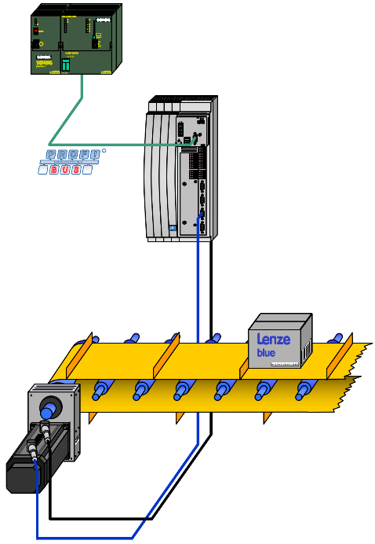  logic PLC  (PROFIBUS master)  9300 servo inverter  EMF2133IB  (PROFIBUS slave module) | 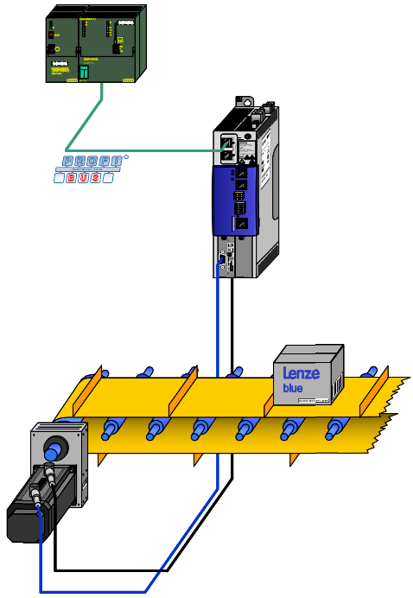  logic PLC  (PROFIBUS master)  i950 servo inverter  I9MAFP0000000S  (PROFIBUS slave module)
Illustration 1: 9300 servo inverter with PROFIBUS module | Illustration 2: i950 servo inverter with PROFIBUS slot module

Note:
In many cases, a one-to-one replacement might be required, not touching the logic PLC’s program.

Three function blocks exist, splitting the AIF fieldbus communication into three sub-functions:
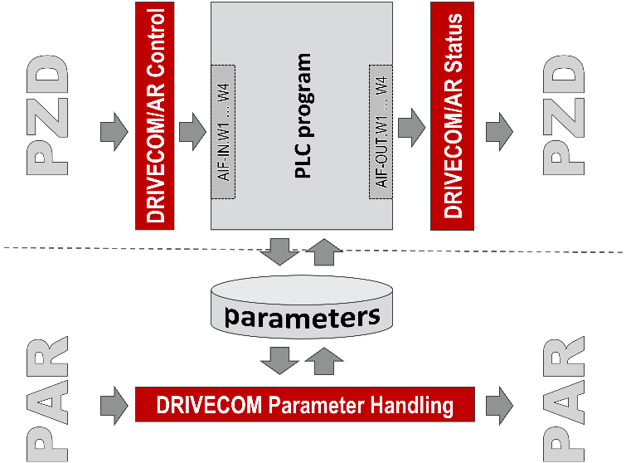
L_ICIP_PROFIBUS_In:
fieldbus process data from the logic PLC
L_ICIP_PROFIBUS_Base:
- fieldbus initialization
- request data of the fieldbus DP V0 parameter channel from the logic PLC (optional)
- response data of the fieldbus DP V0 parameter channel to the logic PLC (optional)
L_ICIP_PROFIBUS_Out:
fieldbus data process data to the logic PLC

Illustration 3: overview on the process data communication (PDO) and parameter channel communication (SDO)

- A function block L_ICIP_PROFIBUS_In to extract the process data control information from the raw data received on PROFIBUS. The method provides the process data in the form of the AIF_IN format of the 9300 servo inverter (see chapters ‎2.2 and ‎3.2).
- A function block L_ICIP_PROFIBUS_Out to compile the complete fieldbus telegram to be transmitted to the logic PLC. The method reads the process data control information in the form of the AIF_Out format of the 9300 servo inverter (see chapters ‎2.3 and ‎3.2).
- The function block L_ICIP_PROFIBUS_Base, processing the communication set-up and the DP V0 parameter channel (see chapter ‎2.1).

Note:
Always declare and call the PROFIBUS function blocks in the following order:
- L_ICIP_PROFIBUS_Base
- L_ICIP_PROFIBUS_In
- L_ICIP_PROFIBUS_Out

Function Block L_ICIP_PROFIBUS_Base
The function block L_ICIP_PROFIBUS_Base must always be integrated in the PLC project for correct initialization of the GSD/GSE configuration. If configured, the block additionally processes the DP V0 parameter channel if selected.

Configuration Mode Selection (GSD/GSE Configuration)
The configuration of the PROFIBUS communication for each slave is defined with the help of the GSD/GSE file. Typically, the scope of PROFIBUS Tx/Rx data is pre-defined during the programming the logic PLC. One out of a pool of possible configurations (see chapter ‎4.1) determines the structure of the PROFIBUS telegram to a slave device.
During the initialization of PROFIBUS communication, the function block L_ICIP_PROFIBUS_Base identifies the selected GSD/GSE configuration as listed in the appendix, chapter ‎4.1. For this purpose, an internal service reads the received GSD configuration.

Set GSD/GSE Configuration (BYTE ARRAY[23])
The requested GSD configuration is polled by the function block L_ICIP_PROFIBUS_Base continuously to check for a new GSD/GSE configuration:

byte length of the new GSD configuration (green-colored part of data)
set GSD configuration (1 … 5 bytes, according to chapter ‎4.1)

The active GSD configuration is displayed in index 0x2348:003.

Parameter Handling
Parameter communication must be selected via the GSD/GSE configuration from the logic PLC and is included in the complete Rx/Tx PROFIBUS data. On receiving a valid GSD/GSE configuration (xInit = FALSE), an optional parameter channel (DRIVECOM DP V0) is initialized, if included in the GSD/GSE configuration.

process data communication (PZD)  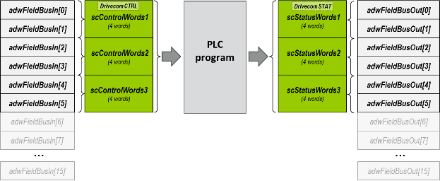 | process data communication (PZD) + parameter channel (PAR)  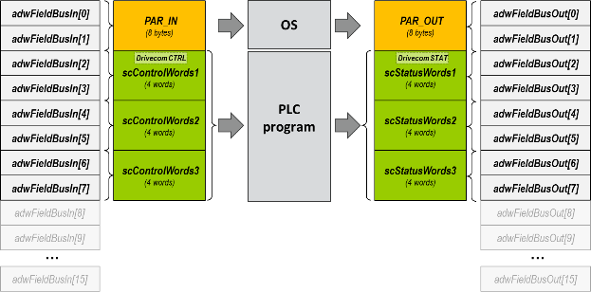
Illustration 4: no parameter channel (PZD only) | Illustration 5: with parameter channel (PZD + PAR)

In case of a parameter channel configured, the lowest 8 bytes of the raw data received on L_ICIP_PROFIBUS_In.adwFieldBusIn / transmit on L_ICIP_PROFIBUS_Out.adwFieldBusOut are interpreted as shown in the appendix, chapters ‎4.6 and ‎4.7.

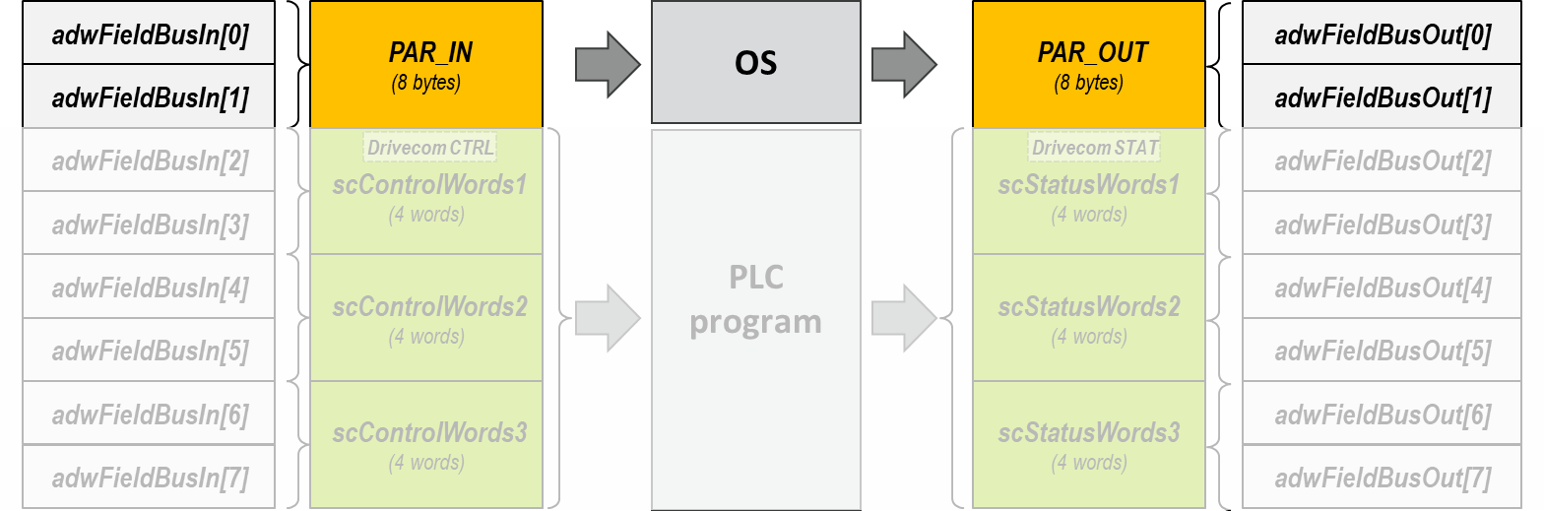

Illustration 6: DP V0 parameter channel data as a part of the complete PROFIBUS telegram

In migration scenarios, the superposed logic PLC might address codes/sub-codes of the Lenze GDC devices 8200/9300 (legacy devices), not available on the i950 servo inverter.

Example:
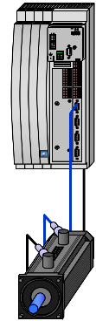 | actual motor speed:  code number: 51  sub-code number: 0  access: read-only  unit: [rpm]  size: 4 byte  scaling factor: 10000 : 1 (FIX32) | 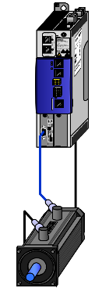 | actual motor speed:  index number: 0x606C  sub-index number: 0  access: read-only  unit: [rpm]  size: 4 byte  scaling factor: 2³¹ : 480000 (‘_s’)
Illustration 7: 9300 servo inverter (legacy product) |  | Illustration 8: i950 servo inverter (actual product)

Because of the mismatch between the old GDC device’s code list and the current i950’s index list, an internal re-mapping of codes/sub-codes to current (user-) indexes is required. The correspondence between old GDC codes and the i950 indexes is defined via a mapping table on the input/output ascParReference.

The generation of the mapping list must be done by the user in the following way:

start
Step 1
Define the number of objects in your mapping list: The amount of objects defines on how many different codes/indexes you would like to get access to.

Example: The logic PLC uses the DP V0 parameter channel to read the following codes from a 9300 servo inverter:
- C0051/000: actual motor speed, scaled in [rpm]
- C0053/000: actual DC bus voltage, scaled in [V]
- C0063/000: actual motor temperature, scaled in [°C]
In this example, the mapping list requires three entries.

Step 2
In the i950’s PLC program, declare a data array with a corresponding number of entries of type L_ICIP_sc93ParReference as follows:
ascParReference: ARRAY[1..3] OF L_ICIP_sc93ParReference; // mapping table

Extend the declaration of step 2 by assigning initialization values to the mapping table’s data array:
Step 3
ascParReference: ARRAY[1..4] OF L_ICIP_sc93ParReference := [ // mapping table
(wCode:=11, wSubCode:=0, wIndex:=16#5500, bySubIndex:=1, bySize:=8, diNum:=10000, diDen:=1),
(wCode:=51, wSubCode:=0, wIndex:=16#606C, bySubIndex:=0, bySize:=4, diNum:=1171875, diDen:=524288),
(wCode:=53, wSubCode:=0, wIndex:=16#6079, bySubIndex:=0, bySize:=4, diNum:=10, diDen:=1),
(wCode:=63, wSubCode:=0, wIndex:=16#2D49, bySubIndex:=5, bySize:=2, diNum:=1000, diDen:=1)];

 | How to find the values for the numerator/denominator ratio?  The numerator/denominator scales a raw value of the physical Lenze device to the raw value of the legacy Lenze device.  Example: The numerator/denominator value for the actual motor speed results from the scaling ratio of the i950 servo inverter (0x606C:000) and the Lenze legacy product (C0051/000):  scaling ratio of the physical Lenze device (i950)  You can look-up the index scaling factors in the parameter list’s tool tips of »EASY Starter«.  $$\frac{diNum}{diDen}=\frac{480000[rpm]}{2^{31}}∙\frac{10000}{1}=\frac{4800000000}{2147483648}=\frac{1171875}{524288}$$  scaling ratio of the legacy Lenze device (9300)  You can look-up the code scaling factors in the 9300’s reference manual in the attribute table.  ^{*)} use greatest common denominator calculations to shorten the numbers for the numerator/denominator

Assign the mapping table’s data array to the function block L_ICIP_PROFIBUS_Base:
Step 4
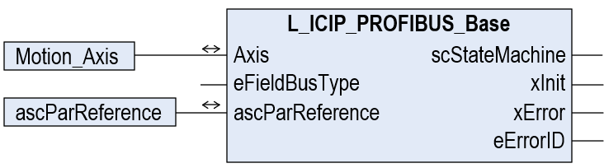
Assign the mapping table array ascParReference to the corresponding input of L_ICIP_PROFIBUS_Base.

Tip:
Call the function block L_ICIP_PROFIBUS_Base in a freewheeling task with low priority to unload the high-priority motion task.
Still, the function blocks L_ICIP_PROFIBUS_In and L_ICIP_PROFIBUS_Out for process data may be called in the high-priority motion task.

end

Note:
In contrary to the 9300 series, i950 allows parameters using a floating-point data type (LREAL) with 8 bytes data size. Even this i950 parameter type can be handled by the function block L_ICIP_PROFIBUS_Base.
To receive a data value with four decimal remainder digits on your machine PLC, apply a numerator/denominator scaling of diNum = 10000 and diDen = 1 in the parameter reference list.

To monitor the parameter channel, the function block L_ICIP_PROFIBUS_Base includes a built-in visualization screen:
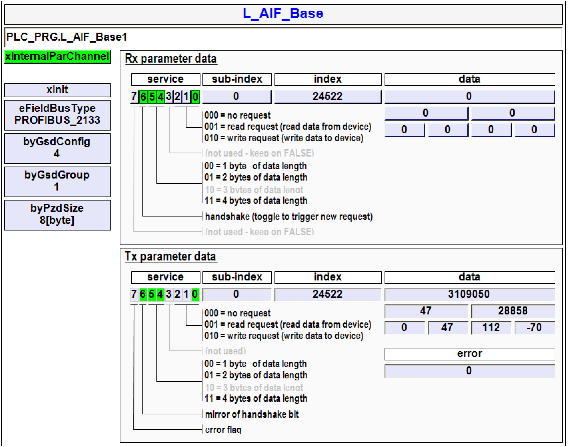
You can test the internal function of the parameter channel by activating the xInternalParChannel button in the top left of the visualization screen.
After activation of the internal parameter channel control, you can use the input fields in the “Rx parameter data” block to simulate the parameter channel of the PLC and check the i950’s response telegram for plausibility.
PLC_PRG.L_ICIP_PROFIBUS_Base1
Illustration 9: built-in visualization screen of function block L_ICIP_PROFIBUS_Base

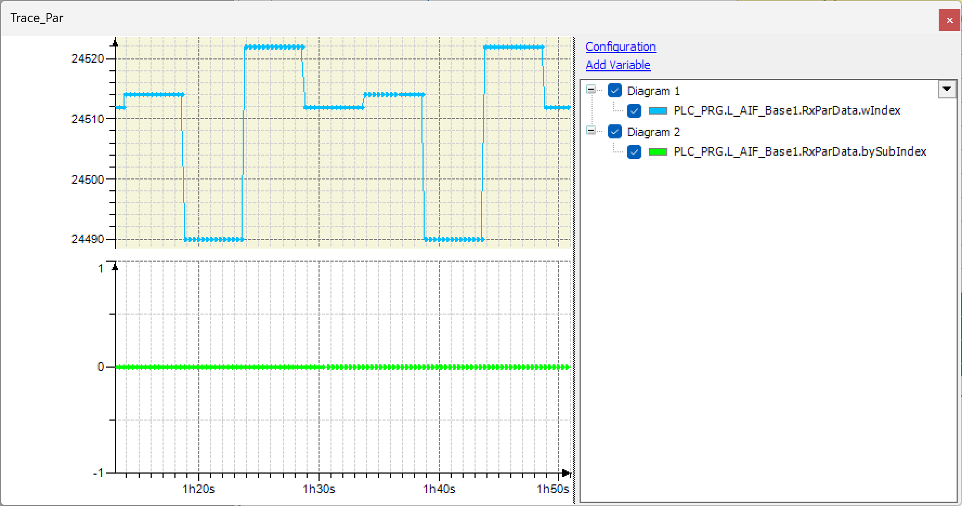 | How to find out about which parameters/indexes are accessed by the logic PLC  Sometimes the logic PLC program is not available. In this case the parameters accessed by the logic PLCs are not known in beforehand and cannot be considered in the reference list.  An easy way to get an overview is to trace the parameter request telegrams of the DP V0 parameter channel. Proceed as follows:  - In the PLC project of the i950 drive, insert a new trace in »PLC Designer«.  - Add the following variables of the parameter channel Rx/Tx telegrams to the trace:  - Rx index (L_ICIP_PROFIBUS_Base1.RxParData.wIndex)  - Rx sub-index (L_ICIP_PROFIBUS_Base1.RxParData.bySubIndex)  - Start the trace while the logic PLC tries to access the drive parameters via the DP V0 parameter channel.  - Activate a measuring cursor in the trace: The values measured on the Rx index and Rx sub-index indicate the drive parameters which the logic PLC tries to access.  Index 24522 / sub-index 0 (= C0053/000): DC bus voltage  Index 24512 / sub-index 0 (= C0063/000): motor temperature  Index 24514 / sub-index 0 (= C0061/000): heatsink temperature  Index 24490 / sub-index 0 (= C0085/000): motor leakage inductance  Illustration 10: example for a trace monitoring the parameter access of the PLC (SDO)

Incompatibility List
The following functions are not implemented in the function block L_ICIP_PROFIBUS_Base:
- No PROFIsafe protocol on i950 PROFIBUS is supported.
- Parameter/index numbers do not match between 9300 and i950. Apply a correspondence list as a reference between the parameters of a Lenze legacy device and an i950 drive controller as shown in the previous chapter ‎2.1.2.

Interface
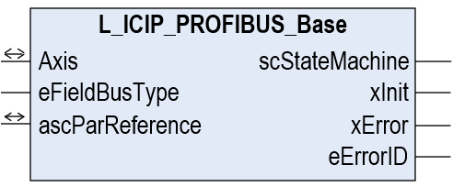
Illustration 11: interface of function block L_ICIP_PROFIBUS_Base

Task Information
Call-up possible from: | freewheeling task | time-controlled task (INTERVAL) | event-controlled task (EVENT) | interrupt task

Note:
Make sure to have included the CAA Memory library in your PLC project to get a fault-free built of your code.

Inputs and Outputs
Identifier  Data type | Description
Axis  AXIS_REF | reference to the connected drive axis  In case of an i950 application, always assign the Motion_Axis to this signal.
ascParReference  ARRAY [*] OF L_ICIP_sc93ParReference | parameter correspondence list  This list defines the correspondence between 9300 codes and i950 indexes. As parameter values are stored in indexes, which have different numbers on 9300 and i950, the list allows to …  - … link a 9300 code to an i950 index  - … consider a scaling numerator/denominator factor between the 9300 parameter value and the i950 index value  Find a detailed overview of the structure ascParReference in chapter ‎2.1.7 (next page).

Inputs
Identifier  Data type | Description
eFieldBusType  L_ICIP_eFieldBusType | type of fieldbus  In the default, this signal is set to 1 (‘PROFIBUS_2133’)  So far, this variable is not used in the function block L_ICIP_PROFIBUS_Base, as the PROFIBUS function blocks only support PROFIBUS communication.  Note: In future, the input may allow to support various fieldbus systems Lenze offered on the 9300 series such as CAN, INTERBUS, …

User-Defined Variable Structure L_ICIP_sc93ParReference
The structure serves to define the parameter correspondence on the PROFIBUS level and the i950 level. The following elements are part of this variable structure:

Identifier  Data type | Description
wCode  WORD | code number of the 9300 servo drive  Note: The 9300 code number results from subtracting the index value (byte 3 and 4 of the parameter channel) from a fixed value of 24575 (0x5FFF).
bySubCode  BYTE | sub-code number of the 9300 servo drive
wIndex  WORD | corresponding index number of the i950 servo drive
bySubIndex  BYTE | sub-index number of the i950 servo drive
bySize  BYTE | data size of the i950’s index value  Note: This information is required, as the data size of the i950’s index value does not necessarily match the data size of the 9300 code value.
diNum  diDen  BYTE | scaling factor between the 9300 code value and the i950 index value (split to numerator/denominator values)  The values for the scaling numerator/denominator can be obtained as shown on the next page. More details can be found in chapter ‎2.1.2.

Note:
An application example is given in the appendix in chapter ‎2.1.2.

Example: calculation of scaling numerator/denominator values:
The actual motor speed 0x606C:000 of the i950 servo drive should be read via parameter channel and be returned to the PLC in the 9300 format of code C0051/000:

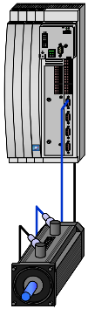 | 9300:  code/sub-code: C0051/000  sample value: 123[rpm]  raw value: 1230000  scaling (numerator): 10000  scaling (denominator): 1 |  | 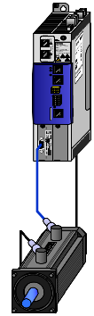 | i950:  code/sub-code: 0x606C:000  sample value: 123[rpm]  raw value: 550293  scaling (numerator): 1073741824  scaling (denominator): 240000
Illustration 12: code scaling 9300 |  |  | Illustration 13: code scaling i950

From the above example, the total numerator/denominator values diNum and diDen can be calculated:
$$\frac{diNum}{diDen}=\frac{\frac{10000}{1}}{\frac{1073741824}{240000}}=\frac{2400000000}{1073741824}=\frac{1171875}{524288}$$

Outputs
Identifier  Data type | Description
scStateMachine  L_ICIP_scStateMachine | data of the communication state machine  This value must be connected to the corresponding input/output variables of the function blocks L_ICIP_PROFIBUS_In and L_ICIP_PROFIBUS_Out to ensure consistent operation of the PROFIBUS function blocks. A detailed description is given on the next page.
xInit  BOOL | status signal: initialization of the GSD/GSE configuration ongoing
xInit  BOOL |  | FALSE | GSD/GSE configuration has finished without errors
xInit  BOOL |  | TRUE | GSD/GSE configuration ongoing/has finished with errors
xError  BOOL | status signal: error during GSD/GSE configuration
xError  BOOL |  | FALSE | no error during GSD/GSE configuration.
xError  BOOL |  | TRUE | An error occurred during GSD/GSE configuration:  - Initialization sequence cannot be terminated – status signal xInit remains on TRUE.  - Refer to the wError output for more information.
eErrorID  WORD | current error ID:
eErrorID  WORD |  | 0: | no error active
eErrorID  WORD |  | 110: | GSD/GSE configuration could not be identified – please select a GSD/GSE configuration as listed in chapter.‎4.1
eErrorID  WORD | Notes:

User-Defined Variable Structure L_ICIP_scStateMachine
This variable structure comprises general data of the fieldbus communication, depending on the fieldbus type active:

Identifier  Data type | Description
eFieldBusType  L_ICIP_eFieldBusType | current error ID:
eFieldBusType  L_ICIP_eFieldBusType |  | PROFIBUS_2133: |  |  |  | The L_ICIP_PROFIBUS function blocks behave like the EMF2133IB PROFIBUS module for 9300.
eFieldBusType  L_ICIP_eFieldBusType | Notes: So far, only ‘PROFIBUS_2131’ and ‘PROFIBUS_2133’ are supported.
byGsdConfig  BYTE | number of the active GSD/GSE configuration found during communication initialization  A complete overview on all possible GSD/GSE configurations is listed in chapter ‎4.1.
byGsdGroup  BYTE | group of the active GSD/GSE configuration of the active GSD/GSE configuration, set-up during communication initialization  A complete overview on all possible GSD/GSE configurations is listed in chapter ‎4.1.
byGsdGroup  BYTE | current error ID:
byGsdGroup  BYTE |  | 1: | no parameter channel / process data (Drivecom control)
byGsdGroup  BYTE |  | 2: | consistent Drivecom parameter channel / process data (Drivecom control)
byGsdGroup  BYTE |  | 3: | consistent Drivecom parameter channel / consistent process data (Drivecom control)
byGsdGroup  BYTE |  | 4: | Drivecom parameter channel / process data (Drivecom control)
byGsdGroup  BYTE |  | 5: | Drivecom parameter channel / consistent process data (Drivecom control)
byGsdGroup  BYTE |  | 6: | no parameter channel / consistent process data (Drivecom control)
byGsdGroup  BYTE |  | 7: | no parameter channel / process data (Lenze device control)
byGsdGroup  BYTE |  | 8: | consistent Drivecom parameter channel / process data (Lenze device control)
byGsdGroup  BYTE |  | 9: | consistent Drivecom parameter channel / consistent process data (Lenze device control)
byGsdGroup  BYTE |  | 10: | Drivecom parameter channel / process data (Lenze device control)
byGsdGroup  BYTE |  | 11: | Drivecom parameter channel / consistent process data (Lenze device control)
byGsdGroup  BYTE |  | 12: | no parameter channel / consistent process data (Lenze device control)
byGsdGroup  BYTE | Notes: A complete overview on all possible GSD/GSE configurations is listed in chapter ‎4.1.
byPzdSize  BYTE | size of the process data (PZD), scaled in [byte]
wDrivecomCtrl  BYTE | Drivecom control word  This variable is only used in a configuration with Drivecom process data communication (byGsdGroup = 1 … 6). The meaning of each control bit of wDrivecomCtrl is explained in the appendix in chapter ‎4.4.
wDrivecomStat  BYTE | Drivecom status word  This variable is only used in a configuration with Drivecom process data communication (byGsdGroup = 1 … 6). The meaning of each control bit of wDrivecomStat is explained in the appendix in chapter ‎4.5.
eDrivecomState  L_ICIP_eDrivecomState | current state of the Drivecom state machine:
eDrivecomState  L_ICIP_eDrivecomState |  | 0: |  | NOT_READY_TO_SWITCH_ON
eDrivecomState  L_ICIP_eDrivecomState |  | 32: |  | SWITCH_ON_INHIBIT
eDrivecomState  L_ICIP_eDrivecomState |  | 1: |  | READY_TO_SWITCH_ON
eDrivecomState  L_ICIP_eDrivecomState |  | 3: |  | SWITCHED_ON
eDrivecomState  L_ICIP_eDrivecomState |  | 23: |  | QUICK_STOP_ACTIVE
eDrivecomState  L_ICIP_eDrivecomState |  | 7: |  | OPERATION_ENABLED
eDrivecomState  L_ICIP_eDrivecomState |  | 15: |  | FAULT_REACTION_ACTIVE
eDrivecomState  L_ICIP_eDrivecomState |  | 8: |  | FAULT
eDrivecomState  L_ICIP_eDrivecomState | Notes: This variable is only used in a configuration with Drivecom process data communication (byGsdGroup = 1 … 6). The Drivecom state machine is shown in chapters ‎2.2.2 and ‎2.3.2.
xInit  BOOL | status signal: initialization of the GSD/GSE configuration ongoing
xInit  BOOL |  | FALSE |  |  | GSD/GSE configuration has finished without errors
xInit  BOOL |  | TRUE |  |  | GSD/GSE configuration ongoing/has finished with errors
xInit  BOOL | Note: This signal mirrors the output signal L_ICIP_PROFIBUS_Base.xInit.
xError  BOOL | status signal: error during GSD/GSE configuration
xError  BOOL |  | FALSE |  |  | no error during GSD/GSE configuration.
xError  BOOL |  | TRUE |  |  | An error occurred during GSD/GSE configuration:  - Initialization sequence cannot be terminated – status signal xInit remains on TRUE.  - Refer to the L_ICIP_PROFIBUS_Base.wError output for more information.
xError  BOOL | Note: This signal mirrors the output signal L_ICIP_PROFIBUS_Base.xError.

Identifier  Data type | Description
adwRawDataIn  ARRAY [0..15] OF DWORD | raw input data on the fieldbus interface  The variable data array is a copy of the fieldbus raw input data in, received on the input adwFieldBusIn of function block L_ICIP_PROFIBUS_In.
adwRawDataOut  ARRAY [0..15] OF DWORD | raw output data on the fieldbus interface  The variable data array is a copy of the fieldbus raw output data in, generated on the output adwFieldBusOut of function block L_ICIP_PROFIBUS_Out.
AxisState  MC_ReadAxisInfo | This structure includes important status signals of the i950 drive:
AxisState  MC_ReadAxisInfo |  | LimitSwitchPos: | positive limit switch has triggered (i.e. on L_TF2P_SpeedControlBase1.scCtrlBasicMotion.xHWLimitPos)
AxisState  MC_ReadAxisInfo |  | LimitSwitchNeg: | negative limit switch has triggered (i.e. on L_TF2P_SpeedControlBase1.scCtrlBasicMotion.xHWLimitNeg)
AxisState  MC_ReadAxisInfo |  | Simulation: | axis is operated in the virtual mode  On an i950 axis, this signal is always FALSE.
AxisState  MC_ReadAxisInfo |  | CommunicationReady: | motion bus communication interface between axis driver (AXIS_REF) and motor control is in operation  On an i950 axis, this signal is always TRUE.
AxisState  MC_ReadAxisInfo |  | ReadyForPowerOn: | drive is ready for being powered on (i.e. via control signal L_TF2P_SpeedControlBase1.xEnableOperation).  This signal state comprises the following states:  - drive is fault-free  - no STO command is active (safe torque off)  - DC bus voltage is switched on
AxisState  MC_ReadAxisInfo |  | PowerOn: | i950 drive is powered on (same status as L_TF2P_SpeedControlBase1.xOperationEnabled)
AxisState  MC_ReadAxisInfo |  | IsHomed: | zero position of the i950 drive’s measuring system is known
AxisState  MC_ReadAxisInfo |  | AxisError: | error in the axis driver (AXIS_REF)
AxisState  MC_ReadAxisInfo |  | AxisWarning: | warning in the axis driver (AXIS_REF)
AxisState  MC_ReadAxisInfo |  | DriveError: | error in the inverter’s motor control
AxisState  MC_ReadAxisInfo |  | DriveWarning: | warning in the inverter’s motor control
AxisState  MC_ReadAxisInfo |  | SWLimitSwitchPos: | positive software limit has triggered
AxisState  MC_ReadAxisInfo |  | SWLimitSwitchNeg: | negative software limit has triggered
AxisState  MC_ReadAxisInfo |  | ReadyForMotion: | drive is ready for receiving motion commands  This signal state comprises the following states:  - drive is enabled  - drive is fault-free  - a motor brake (if available) has opened
AxisState  MC_ReadAxisInfo |  | STOActive: | STO command is active (safe torque off)
AxisState  MC_ReadAxisInfo |  | VoltageEnabled: | DC bus voltage is switched on
AxisState  MC_ReadAxisInfo |  | MotorMagnetised: | motor is magnetization complete
AxisState  MC_ReadAxisInfo |  | QSPApplActive: | quickstop command of the axis driver (AXIS_REF) is active
AxisState  MC_ReadAxisInfo |  | QSPDriveActive: | quickstop command of the inverter’s motor control is active
AxisState  MC_ReadAxisInfo | Find more information about MC_ReadAxisInfo in the »PLC Designer« online help.

Caution:
The above-listed variables are read-only! Never change any of these variables as this may have unpredictable consequences in fieldbus communication and drive behaviour!

Function Block L_ICIP_PROFIBUS_In
The function block L_ICIP_PROFIBUS_In reads 16 double words of the fieldbus input data on the input data array adwFieldBusIn. Once a valid GSD/GSE configuration was detected (scStateMachine.xInit = FALSE), the raw data on the input signal adwFieldBusIn of the function block L_ICIP_PROFIBUS_In are mapped to …

- process data PZD
- parameter data PAR (optional, if selected, see chapter ‎2.1.2)

process data communication (PZD) | process data communication (PZD) + parameter channel (PAR)
Illustration 14: no parameter channel (PZD only) | Illustration 15: with parameter channel (PZD + PAR)

Note:
The i950 PROFIBUS slot module handles up to 16 double words of input data. The function block L_ICIP_PROFIBUS_In only processes the double words 0 to 7. The double word 8 to 15 are not considered in the evaluation of the fieldbus raw data.
However, always assign a data array ARRAY [0..15] OF DWORD to the input signal L_ICIP_PROFIBUS_In.adwFieldBusIn.

Process Data (PZD)
In any case, process data exchange is part of the fieldbus communication. The function block L_ICIP_PROFIBUS_In handles the process input data of the fieldbus system and converts the raw data received on adwFieldBusIn to the data structures known from the 8200/9300 device series.
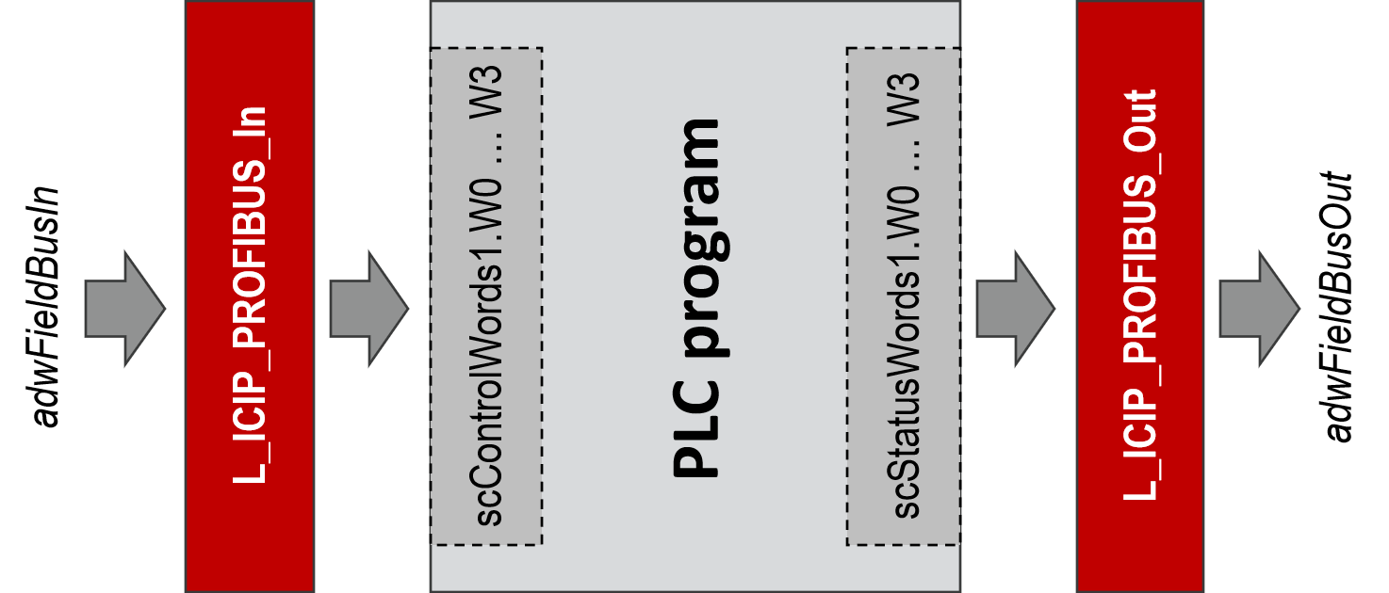
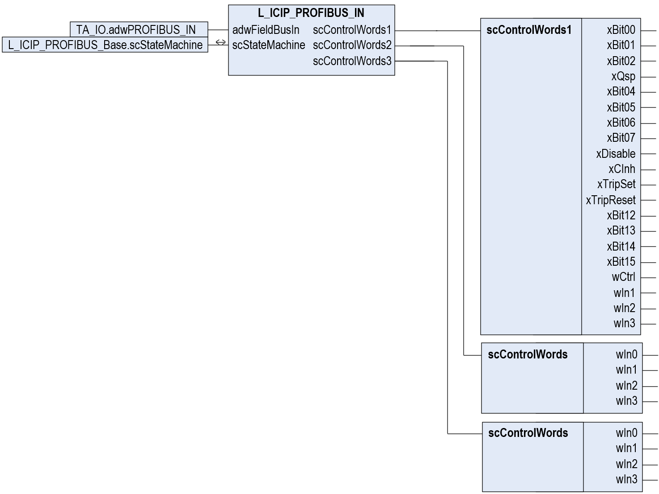
L_ICIP_PROFIBUS_In:

conversion of the of raw input process data adwFieldBusIn to the data sets scControlWords1, scControlWords2 and scControlWords 3
(16 DWORD)
raw input data from the fieldbus module
(16 DWORD)
(motion) technology application using the legacy AIF interface

Illustration 16: principle of process input data handling / detailed signal list of the scControlWords interfaces of function block L_ICIP_PROFIBUS_In

Drivecom State Machine
Depending on the GSD/GSE configuration, the first process input data word scControlWords1.wCtrl is processed via the Drivecom state machine:
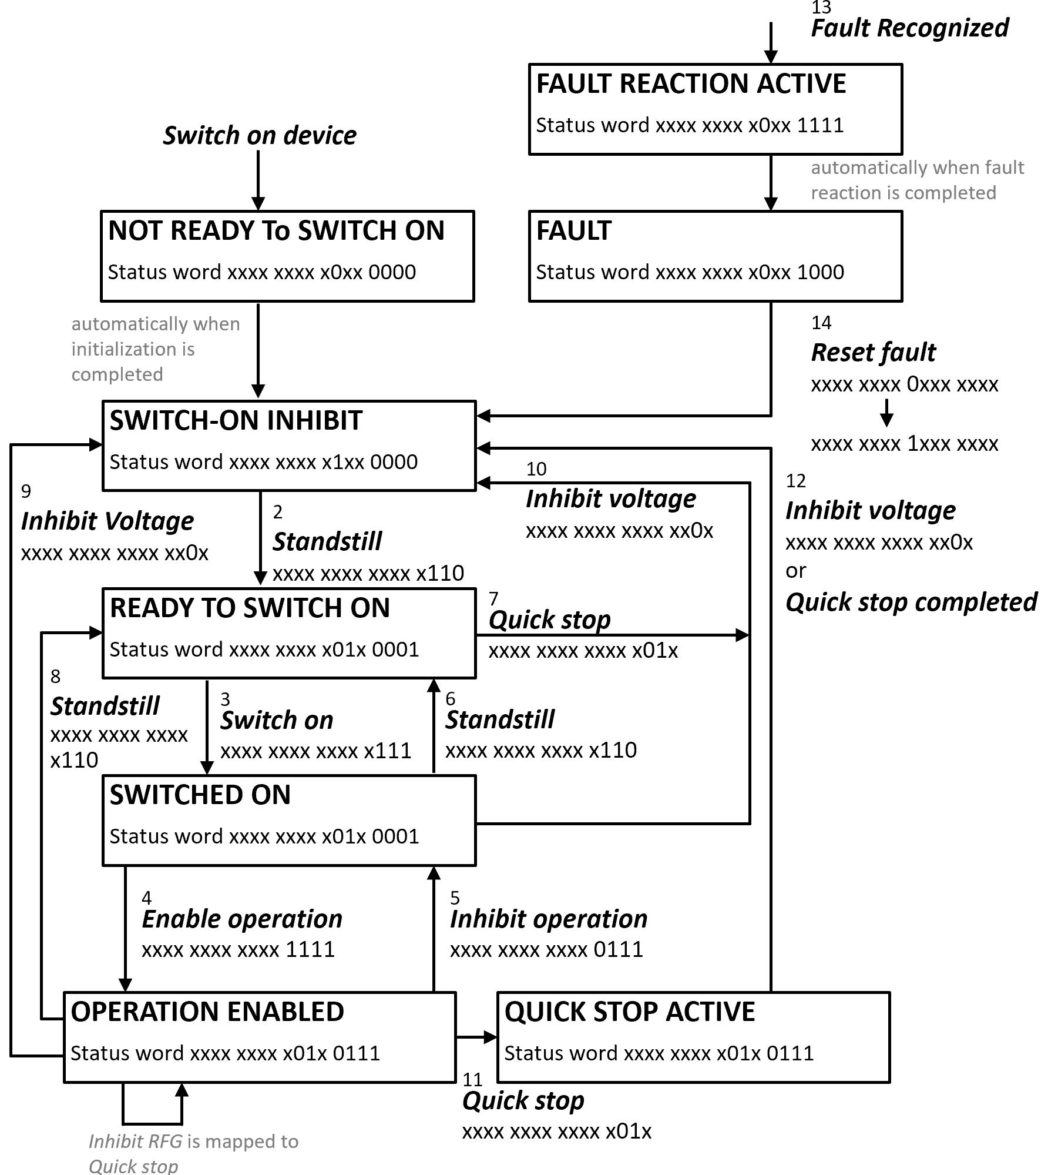

Illustration 17: flow chart of the Drivecom state machine (affecting control/status word 1)

The actual state of the Drivecom state machine is displayed on the variable scStateMachine.eDrivecomState.

Incompatibility List
The following functions are not implemented in the function block L_ICIP_PROFIBUS_In:
- The output scControlWords1.wCtrl.xTripSet does not find a corresponding function in the FAST technology modules. The user can evaluate this signal to set a user-defined error.
- Facing an undervoltage state during drive operation leads to an error, as the PLCopen state machine is violated. On 9300 an undervoltage state during drive operating was resulting in a message only.
- The STO command of i950 must be released to achieve the same behavior of the Drivecom state machine as on 9300. If the i950’s STO command is active, the Drivecom state machine remains in the state Switch-On Inhibited.
Using GSD configurations with Lenze device control (AR), the STO command keeps the xDisable control signal active, meaning the drive cannot be activated.
- The L_ICIP_PROFIBUS_In function block supports the following device control methods:
  - Drivecom
  - Lenze device control (AR)
The PROFIdrive control method is not supported.

Interface
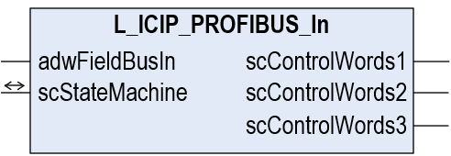
Illustration 18: interface of function block L_ICIP_PROFIBUS_In

Task Information
Call-up possible from: | freewheeling task | time-controlled task (INTERVAL) | event-controlled task (EVENT) | interrupt task

Note:
Make sure to have included the CAA Memory library in your PLC project to get a fault-free built of your code.

Inputs and Outputs
Identifier  Data type | Description
scStateMachine  L_ICIP_scStateMachine | data of the communication state machine  Connect the corresponding output scStateMachine of function block L_ICIP_PROFIBUS_Base to ensure consistent operation of the PROFIBUS function blocks. A detailed description of this variable structure is given in chapter ‎2.1.8.

Inputs
Identifier  Data type | Description
adwFieldBusIn  ARRAY [0..15] OF DWORD | input of the fieldbus raw data  These values can directly be mapped to the input data of the fieldbus IO interface.

Outputs
Identifier  Data type | Description
scControlWords1  L_ICIP_scControlWords1 | AIF fieldbus input data (first group)  The values comprise a four-word data structure, following the structure of the AIF-IN system block of the 9300 servo inverter. A detailed description is given on the next page.
scControlWords2  L_ICIP_scControlWords | AIF fieldbus input data (second group)  The values comprise a four-word data structure, following the structure of the AIF-IN system block of the 9300 ServoPLC inverter. A detailed description is given on the next pages.
scControlWords3  L_ICIP_scControlWords | AIF fieldbus input data (third group)  The values comprise a four-word data structure, following the structure of the AIF-IN system block of the 9300 ServoPLC inverter. A detailed description is given on the next pages.

User-Defined Variable Structure L_ICIP_scControlWords1
This structure implements the AIF-IN interface known from the 9300 servo inverter series. It includes the following elements:

Identifier  Data type | Description
xBit00  BIT | bit 0 of the control word
xBit00  BIT |  | FALSE: | control function deactivated
xBit00  BIT |  | TRUE: | control function activated
xBit00  BIT | Note: This bit does not have a fixed meaning but can be connected freely by the user.
xBit01  BIT | bit 1 of the control word
xBit01  BIT |  | FALSE: | control function deactivated
xBit01  BIT |  | TRUE: | control function activated
xBit01  BIT | Note: This bit does not have a fixed meaning but can be connected freely by the user.
xBit02  BIT | bit 2 of the control word
xBit02  BIT |  | FALSE: | control function deactivated
xBit02  BIT |  | TRUE: | control function activated
xBit02  BIT | Note: This bit does not have a fixed meaning but can be connected freely by the user.
xQsp  BIT | bit 3 of the control word: activate quick stop
xQsp  BIT |  | FALSE: | quick stop not activated
xQsp  BIT |  | TRUE: | quick stop activated
xQsp  BIT | Note: This bit must be connected to a quick stop command in the application (i.e. implemented by the function blocks MC_Stop, L_MC1P_SetQuickStopAppl, …).
xBit04  BIT | bit 4 of the control word
xBit04  BIT |  | FALSE: | control function deactivated
xBit04  BIT |  | TRUE: | control function activated
xBit04  BIT | Note: This bit does not have a fixed meaning but can be connected freely by the user.
xBit05  BIT | bit 5 of the control word
xBit05  BIT |  | FALSE: | control function deactivated
xBit05  BIT |  | TRUE: | control function activated
xBit05  BIT | Note: This bit does not have a fixed meaning but can be connected freely by the user.
xBit06  BIT | bit 6 of the control word
xBit06  BIT |  | FALSE: | control function deactivated
xBit06  BIT |  | TRUE: | control function activated
xBit06  BIT | Note: This bit does not have a fixed meaning but can be connected freely by the user.
xBit07  BIT | bit 7 of the control word
xBit07  BIT |  | FALSE: | control function deactivated
xBit07  BIT |  | TRUE: | control function activated
xBit07  BIT | Note: This bit does not have a fixed meaning but can be connected freely by the user.
xDisable  BIT | bit 08 of the control word: disable the drive
xDisable  BIT |  | FALSE: | do not disable drive (xCInh=FALSE leads to power-up the drive)
xDisable  BIT |  | TRUE: | disable drive (xCInh=FALSE has no effect)
xDisable  BIT | Notes:  - Use this bit to interlock enabling the drive’s operation. On xDisable=TRUE, the drive must remain shut-down, even if xCInh is on FALSE.  - If xDisable is on TRUE, the ‘drive ready’ status remains on FALSE.
xCInh  BIT | bit 09 of the control word: inhibit the drive controller
xCInh  BIT |  | FALSE: | drive controller enabled
xCInh  BIT |  | TRUE: | drive controller inhibited
xCInh  BIT | Notes:  - The bit is used to power-up the drive (i.e. by means of the MC_Power function block).  - If xDisable is on TRUE, the xCInh control bit has no effect.

Identifier  Data type | Description
xTripSet  BIT | bit 10 of the control word: set a user error on the drive
xTripSet  BIT |  | FALSE: | user error is triggered
xTripSet  BIT |  | TRUE: | no user error is triggered
xTripSet  BIT | Note: As there is no corresponding function in the operating system of i950 available, the xTripSet bit has no practical meaning.
xTripReset  BIT | bit 11 of the control word: error reset command
xTripReset  BIT |  | FALSE=>TRUE |  | reset error command
xTripReset  BIT | Notes:  - The bit is used to reset an error on the drive (i.e. by means of the MC_Reset function block).  - Resetting an error only works if the cause of the error does not apply any more.
xBit12  BIT | bit 12 of the control word
xBit12  BIT |  | FALSE: | control function deactivated
xBit12  BIT |  | TRUE: | control function activated
xBit12  BIT | Note: This bit does not have a fixed meaning but can be connected freely by the user.
xBit13  BIT | bit 13 of the control word
xBit13  BIT |  | FALSE: | control function deactivated
xBit13  BIT |  | TRUE: | control function activated
xBit13  BIT | Note: This bit does not have a fixed meaning but can be connected freely by the user.
xBit14  BIT | bit 14 of the control word
xBit14  BIT |  | FALSE: | control function deactivated
xBit14  BIT |  | TRUE: | control function activated
xBit14  BIT | Note: This bit does not have a fixed meaning but can be connected freely by the user.
xBit15  BIT | bit 15 of the control word
xBit15  BIT |  | FALSE: | control function deactivated
xBit15  BIT |  | TRUE: | control function activated
xBit15  BIT | Note: This bit does not have a fixed meaning but can be connected freely by the user.
wCtrl  WORD | Control word  This control word mirrors the 16 control bits as listed above in a WORD format.
wIn1  WORD | input of a 16 bit integer number  Typically, the second WORD on scControlWords1 is interpreted as the drive’s speed set value, scaled in [%] (0 … 16384 = 0.0 … 100.0[%]). However, it is up to the user to define the meaning in the application.
wIn2  WORD | input of a free 16 bit WORD value
wIn3  WORD | input of a free 16 bit WORD value

Tip:
Do you need to merge and scControlWords1.wIn3 to a 32-bit value? The function PackWordsToDword provides this function. Use it in the following way:
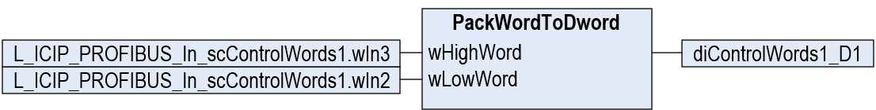
Illustration 19: conversion of two 16-bit WORD values to a 32-bit DWORD value

User-Defined Variable Structure L_ICIP_scControlWords
This structure implements the extended AIF-IN interface known from the 9300 ServoPLC inverter series. It is applied on the objects scControlWords2 and scControlWords3, and includes the following elements:

Identifier  Data type | Description
wIn0  WORD | input of a free 16 bit WORD value
wIn1  WORD | input of a free 16 bit WORD value
wIn2  WORD | input of a free 16 bit WORD value
wIn3  WORD | input of a free 16 bit WORD value

Function Block L_ICIP_PROFIBUS_Out
The function block L_ICIP_PROFIBUS_Out reads the AIF data structure known from the 8200/9300 device series and transfers its information to the 16 fieldbus output double-words on a data array. Once a valid GSD/GSE configuration was detected (scStateMachine.xInit = FALSE), the following data are mapped to the output data array adwFieldBusOut:

- process data PZD from the AIF-OUT objects
- parameter data PAR (optional, if selected, see chapter ‎2.1.2)

process data communication (PZD) | process data communication (PZD) + parameter channel (PAR)
Illustration 20: no parameter channel (PZD only) | Illustration 21: with parameter channel (PZD + PAR)

Note:
The i950 PROFIBUS slot module handles up to 16 double words of output data. The output data range of the function block L_ICIP_PROFIBUS_Out (output adwFieldBusOut) comprises the full scope of 16 double words, even if only double words 0 to 7 are in use.

Process Data (PZD)
In any case, process data exchange is part of the fieldbus communication. The function block L_ICIP_PROFIBUS_Out generates the raw data on adwFieldBusOut from the AIF-OUT objects known from the 8200/9300 series.
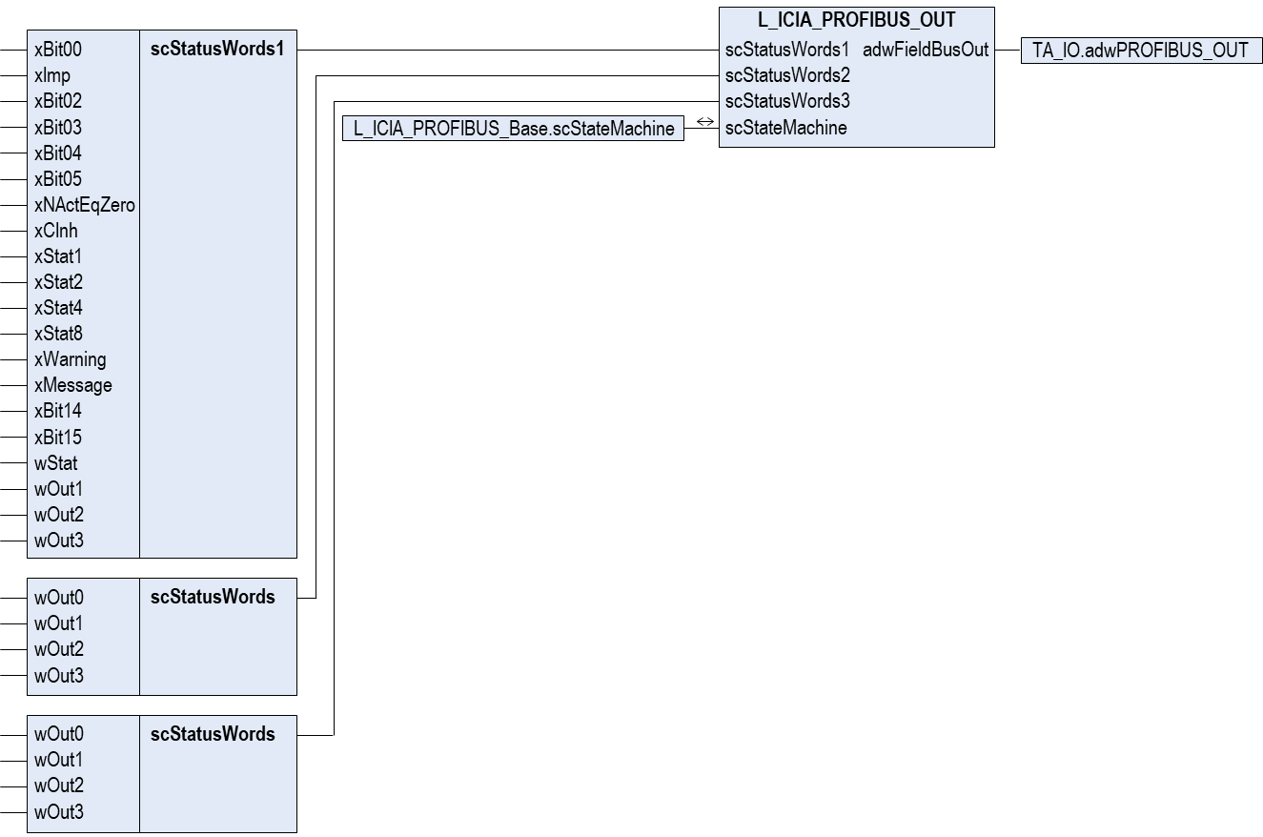
(motion) technology application using the legacy AIF interface
L_ICIP_PROFIBUS_Out:

conversion of the output data set scStatusWords1, scStatusWords2 and scStatusWords3 to raw output process data adwFieldBusOut
(16 DWORD)

raw output data to the PROFIBUS module ???
(16 DWORD)

Illustration 22: principle of process output data handling / detailed signal list of the scStatusWords interfaces of function block L_ICIP_PROFIBUS_In

Tip:
Use the user-defined function block L_STAT to generate the status signals on L_ICIP_PROFIBUS_Out.xStat1 … L_ICIP_PROFIBUS_Out.xStat8.

Drivecom State Machine
Depending on the GSD/GSE configuration, the first process output data word scStatusWords1.wStat is processed via the Drivecom state machine:

Illustration 23: flow chart of the Drivecom state machine (affecting control/status word 1)

The actual state of the Drivecom state machine is displayed on the variable scStateMachine.eDrivecomState.

Incompatibility List
The following functions are not implemented in the function block L_ICIP_PROFIBUS_Out:
- The status bits DCTRL-STAT*1, … DCTRL-STAT*8 do not comprise the full scope of 9300 states. The red-marked states are not supported:
value | DCTRL-STAT*8 | DCTRL-STAT*4 | DCTRL-STAT*2 | DCTRL-STAT*1 | note
0 | 0 | 0 | 0 | 0 | initialization after the supply voltage has been connected
1 | 0 | 0 | 0 | 1 | lock mode, restart protection is active C0142
3 | 0 | 0 | 1 | 1 | drive is in controller inhibit mode
4 | 0 | 1 | 0 | 0 | flying restart active
5 | 0 | 1 | 0 | 1 | DC brake active
6 | 0 | 1 | 1 | 0 | controller enabled
7 | 0 | 1 | 1 | 1 | the release of a monitoring function resulted in a "message"
8 | 1 | 0 | 0 | 0 | the release of a monitoring function resulted in a "trip"
10 | 1 | 0 | 1 | 0 | the release of a monitoring function resulted in a "FAIL-QSP"
15 | 1 | 1 | 1 | 1 | communication fail (PROFIBUS communication module inverter)

- According to PLCopen, an undervoltage on the DC bus results in an error instead of a message. Before restarting the drive, the user must reset the drive error.
- The L_ICIP_PROFIBUS_In function block supports the following device control methods:
  - Drivecom
  - Lenze device control (AR)
The PROFIdrve control method is not supported.

Interface
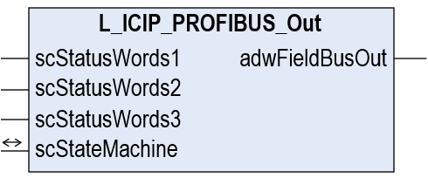
Illustration 24: interface of function block L_ICIP_PROFIBUS_Out

Task Information
Call-up possible from: | freewheeling task | time-controlled task (INTERVAL) | event-controlled task (EVENT) | interrupt task

Note:
Make sure to have included the CAA Memory library in your PLC project to get a fault-free built of your code.

Inputs and Outputs
Identifier  Data type | Description
scStateMachine  L_ICIP_scStateMachine | data of the communication state machine  Connect the corresponding output scStateMachine of function block L_ICIP_PROFIBUS_Base to ensure consistent operation of the AIF function blocks. A detailed description of this variable structure is given in chapter ‎2.1.8.

Inputs
Identifier  Data type | Description
scStatusWords1  L_ICIP_scStatusWords1 | AIF fieldbus output data (first group)  The values comprise a four-word data structure, following the structure of the AIF-OUT system block of the 9300 servo inverter. A detailed description is given on the next page.
scStatusWords2  L_ICIP_scStatusWords | AIF fieldbus output data (second group)  The values comprise a four-word data structure, following the structure of the AIF-OUT system block of the 9300 ServoPLC inverter. A detailed description is given on the next pages.
scStatusWords3  L_ICIP_scStatusWords | AIF fieldbus output data (third group)  The values comprise a four-word data structure, following the structure of the AIF-OUT system block of the 9300 ServoPLC inverter. A detailed description is given on the next pages.

Outputs
Identifier  Data type | Description
adwFieldBusOut  ARRAY [0..15] OF DWORD | output of the fieldbus raw data  These values can directly be mapped to the output data of the fieldbus IO interface.

User-Defined Variable Structure scStatusWords1
This structure implements the AIF-OUT1 interface known from the 9300 servo inverter series. It includes the following elements:

Identifier  Data type | Description
xBit00  BIT | bit 0 of the AIF-OUT status word
xBit00  BIT |  | FALSE: |  |  | status inactive
xBit00  BIT |  | TRUE: |  |  | status active
xBit00  BIT | Note: This bit does not have a fixed meaning but can be connected freely by the user.
xImp  BIT | bit 1 of the AIF-OUT status word: pulse inhibit active
xImp  BIT |  | FALSE: |  |  | The drive’s power stage is active and provides voltage/current to the motor.
xImp  BIT |  | TRUE: |  |  | The drive’s power stage is inactive and no current is applied to the motor.
xImp  BIT | Note: This bit must be connected to the corresponding signal in the application (i.e. by the status signal xImpActive of function block L_TB2P_AxisInterface).
xBit02  BIT | bit 2 of the AIF-OUT status word
xBit02  BIT |  | FALSE: |  |  | status inactive
xBit02  BIT |  | TRUE: |  |  | status active
xBit02  BIT | Note: This bit does not have a fixed meaning but can be connected freely by the user.
xBit03  BIT | bit 3 of the AIF-OUT status word
xBit03  BIT |  | FALSE: |  |  | status inactive
xBit03  BIT |  | TRUE: |  |  | status active
xBit03  BIT | Note: This bit does not have a fixed meaning but can be connected freely by the user.
xBit04  BIT | bit 4 of the AIF-OUT status word
xBit04  BIT |  | FALSE: |  |  | status inactive
xBit04  BIT |  | TRUE: |  |  | status active
xBit04  BIT | Note: This bit does not have a fixed meaning but can be connected freely by the user.
xBit05  BIT | bit 5 of the AIF-OUT status word
xBit05  BIT |  | FALSE: |  |  | status inactive
xBit05  BIT |  | TRUE: |  |  | status active
xBit05  BIT | Note: This bit does not have a fixed meaning but can be connected freely by the user.
xNActEqZero  BIT | bit 6 of the AIF-OUT status word: drive speed signal is zero
xNActEqZero  BIT |  | FALSE: |  |  | drive is moving (absolute drive speed is greater than the speed tolerance window)
xNActEqZero  BIT |  | TRUE: |  |  | drive is in standstill (absolute drive speed below the speed tolerance window)
xNActEqZero  BIT | Note: Generate this signal by a suitable logic (i.e. (ABS(MCTRL_nNAct_v)<=scPar.wC0019_Nmin)).
xCInh  BIT | bit 7 of the AIF-OUT status word: drive controllers are inhibited
xCInh  BIT |  | FALSE: |  |  | position/speed/current control is active
xCInh  BIT |  | TRUE: |  |  | position/speed/current control is reset
xCInh  BIT | Note: This bit must be connected to the corresponding signal in the application (i.e. by the status signal Status of function block MC_Power).
xStat1  xStat2  xStat4  xStat8  BIT | bits 8 to 11 of the AIF-OUT status word: indication of the drive state
xStat1  xStat2  xStat4  xStat8  BIT |  | xStat8 | xStat4 | xStat2 |  | xStat1
xStat1  xStat2  xStat4  xStat8  BIT |  | 0 | 0 | 0 |  | 0 | initialisation after the supply voltage has been connected
xStat1  xStat2  xStat4  xStat8  BIT |  | 0 | 0 | 1 |  | 1 | drive is in controller inhibit state
xStat1  xStat2  xStat4  xStat8  BIT |  | 0 | 1 | 1 |  | 0 | controller is enabled
xStat1  xStat2  xStat4  xStat8  BIT |  | 0 | 1 | 1 |  | 1 | a monitoring function triggered in a "message"
xStat1  xStat2  xStat4  xStat8  BIT |  | 1 | 0 | 0 |  | 0 | a monitoring function triggered in a "fault"
xStat1  xStat2  xStat4  xStat8  BIT |  | 1 | 0 | 1 |  | 0 | a monitoring function triggered in a "FAIL-QSP"
xStat1  xStat2  xStat4  xStat8  BIT | Notes: These bits must be connected to the corresponding signal in the application (i.e. by the status signals of function block L_TB2P_AxisInterface). Some states known from 9300 may not be possible to be indicated (see chapter ‎2.3.3).

Identifier  Data type | Description
xWarning  BIT | bit 12 of the AIF-OUT status word: warning active
xWarning  BIT |  | FALSE: | no drive warning is active
xWarning  BIT |  | TRUE: | a drive warning is active
xWarning  BIT | Note: This bit must be connected to the corresponding signal in the application (i.e. by the status signals of function block MC_ReadAxisError).
xMessage  BIT | bit 13 of the AIF-OUT status word: message is active (i.e. under-/overvoltage state)
xMessage  BIT |  | FALSE: | no message is active
xMessage  BIT |  | TRUE: | a message is active (i.e. under-/overvoltage state)
xMessage  BIT | Note: This bit must be connected to the corresponding signal in the application (i.e. by the inverted status signal xVoltageEnabled of function block L_TB2P_AxisInterface).
xBit14  BIT | bit 14 of the AIF-OUT status word
xBit14  BIT |  | FALSE: | status inactive
xBit14  BIT |  | TRUE: | status active
xBit14  BIT | Note: This bit does not have a fixed meaning but can be connected freely by the user.
xBit15  BIT | bit 15 of the AIF-OUT status word
xBit15  BIT |  | FALSE: | status inactive
xBit15  BIT |  | TRUE: | status active
xBit15  BIT | Note: This bit does not have a fixed meaning but can be connected freely by the user.
wStat  WORD | AIF-OUT status word  The wStat signal is logically OR-connected with the bits xBit00 … xBit15. This leaves it up to the user if the status is compiled indivually via the Boolean inputs xBit00 … xBit15 or via the wStat status word.
wOut1  WORD | output of a 16 bit integer number  Typically, the second WORD on AIF-OUT1 is interpreted as the drive’s speed set value, scaled in [%] (0 … 16384 = 0.0 … 100.0[%]). However, it is up to the user to define the meaning in the application.
wOut2  WORD | output of a free 16 bit WORD value
wOut3  WORD | output of a free 16 bit WORD value

Tip:
Do you need to split a 32-bit value to two 16-bit values on scStatusWords1.wOut2 and ScStatusWords1.wOut3? The function block UnpackDword provides this function. Use it in the following way:
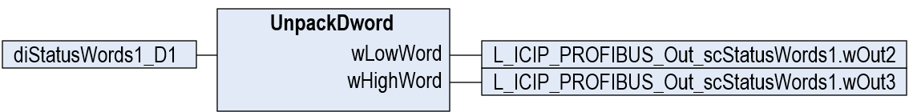
Illustration 25: conversion of a 32-bit DWORD value to two 16-bit WORD values

User-Defined Variable Structure L_ICIP_scStatusWords
This structure implements the extended AIF-OUT interface known from the 9300 ServoPLC inverter series. It is applied on the objects scStatusWords2 and scStatusWords3, and includes the following elements:

Identifier  Data type | Description
wOut0  WORD | output of a free 16 bit WORD value
wOut1  WORD | output of a free 16 bit WORD value
wOut2  WORD | output of a free 16 bit WORD value
wOut3  WORD | output of a free 16 bit WORD value

Application Example

Commissioning Sequence (Motion Application)
Typically, PROFIBUS is not used in new machines as there are more advanced fieldbus systems available such as EtherCAT or PROFInet. The PROFIBUS fieldbus moreover appears in existing machines in operation. This document focusses on previous Lenze servo inverters, which now need to be replaced by the latest device generation of i950 drives. In the best case, the replacement i950 unit requires a functional twin of the previous servo inverter. Instead of the well-known function block connection of the GDC, the PLC program of the i950 bases on Lenze’s technology modules with some slight extensions to generate a 100% functional compatibility between the previous and actual drive system.
The following example shows how to migrate a 9300 servo inverter in speed control to a compatible i950 signal flow, using the Lenze technology module L_TF2P_SpeedControlBase.

Pre-Requisites:
start
- »PLC Designer« is already open on your PC.
- No project is open in »PLC Designer«.

Step 1
Create a new project in »PLC Designer«:
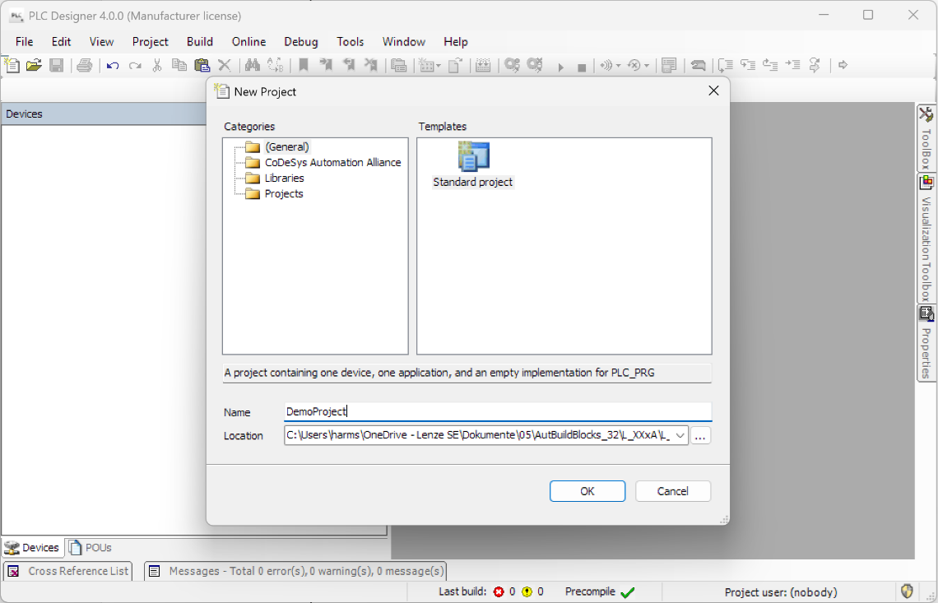
… confirm by clicking Ok.
… assign a project name (file name), …
… select a directory path to store the project and …
… select the empty Standard project, …
Click on New Project …
Illustration 26: creation of a new project in »PLC Designer«

Step 2
Specify the i950 target system:
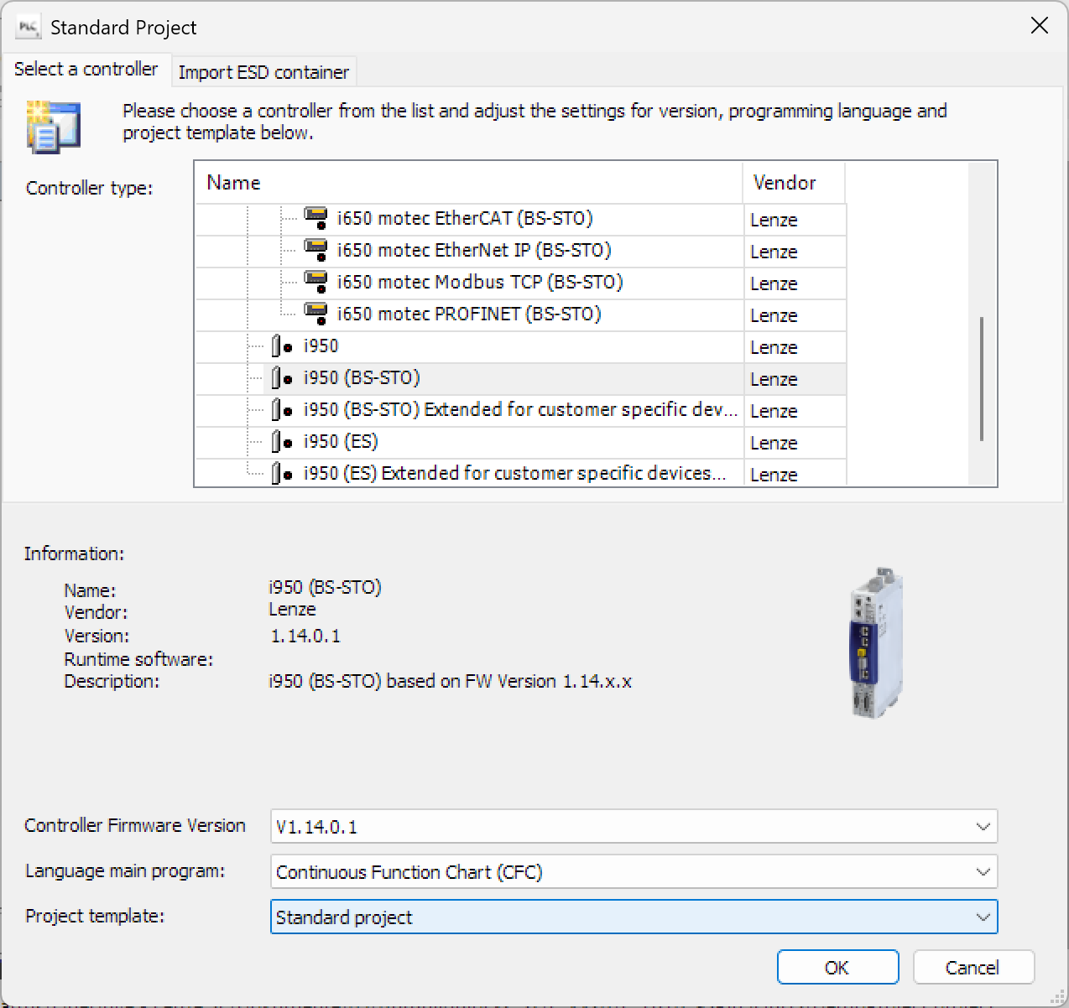
Keep the empty standard project.
As a firmware, choose a version V1.14 or higher.
Select the PLC programming language which you would like to use in your project.
In this example, we use Continuous Function Chart (CFC).
Select a servo inverter i950 (BS) as a target system.
Close the dialogue by clicking Ok.

Illustration 27: select an i950 (BS) with firmware version V1.14 or higher as a target system

Step 3
Execute a Build process to enable access to the commissioning dialogues:
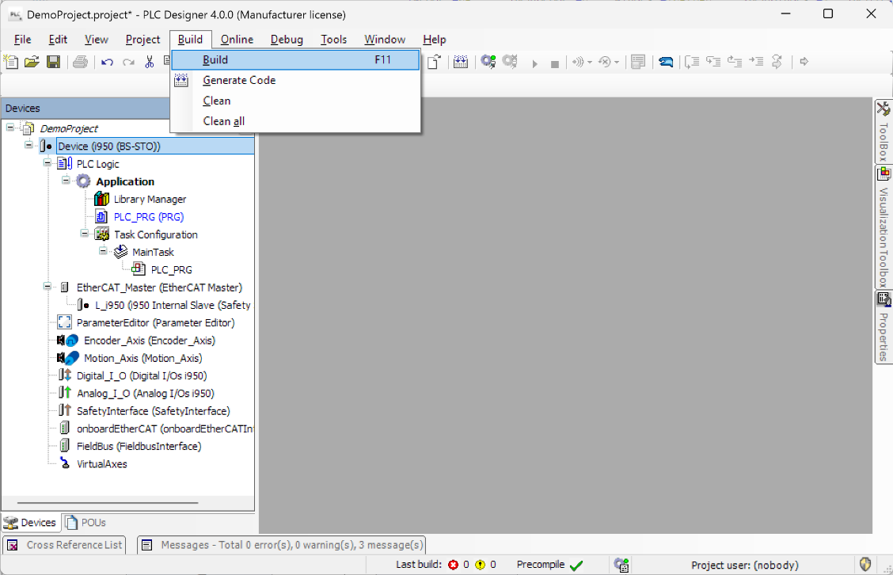
Execute a Build process.
You may also use the keyboards shortcut <F11>.
Illustration 28: Build the project to allow access to the commissioning dialogues of »PLC Designer«

Set the important data in the commissioning dialogues of the device:
Step 4
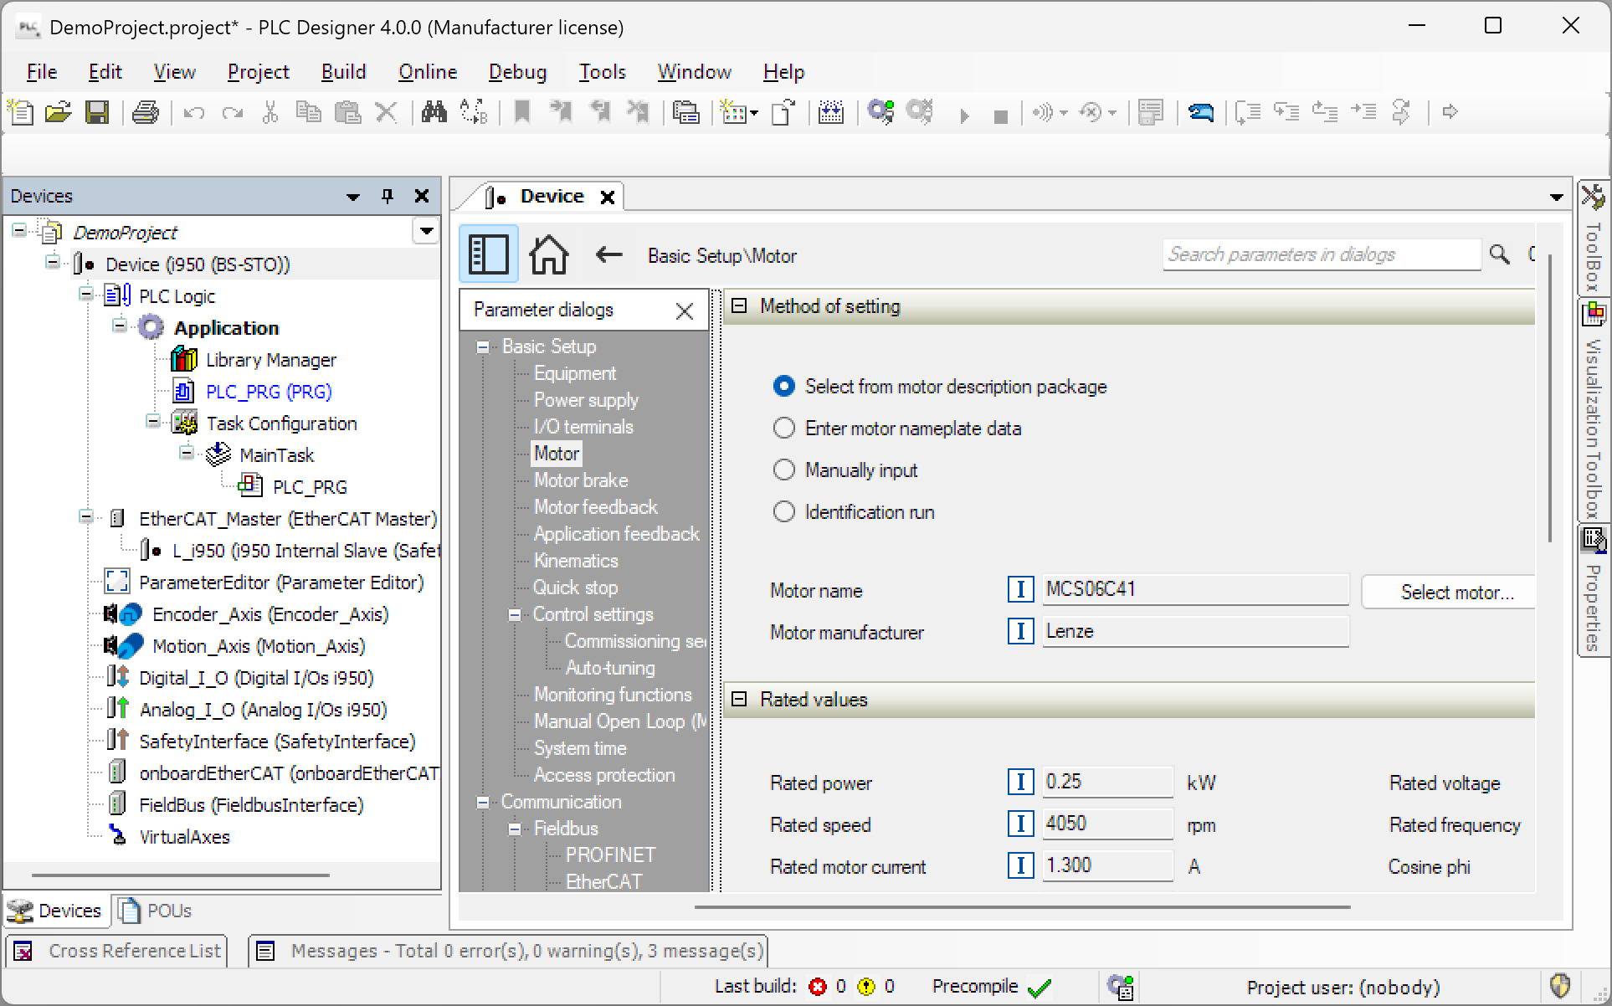
monitoring functions

axis kinematics
quickstop profile
auxiliary motor functions
motor feedback system
motor type/data
mains supply voltage
Illustration 29: basic settings of the i950 drive

- mains supply voltage
- motor data
- motor brake (if mounted/wired)
- motor feedback system
- axis kinematics (gearbox ratio, feed constant, …)
- quickstop profile parameters
- monitoring functions (following error, end switches, …)

Tips:
- Use the motor catalogue of »PLC Designer« to quickly find/set the motor data.
- The auto-tuning feature of the i950 allows to find optimum controller settings for dynamic response of the servo drive.

Open the Library Manager to add the L_TF2P_TechModulesFollowingPositioning library to your project:
Step 5
Double-click the Library Manager to open the list of included libraries.
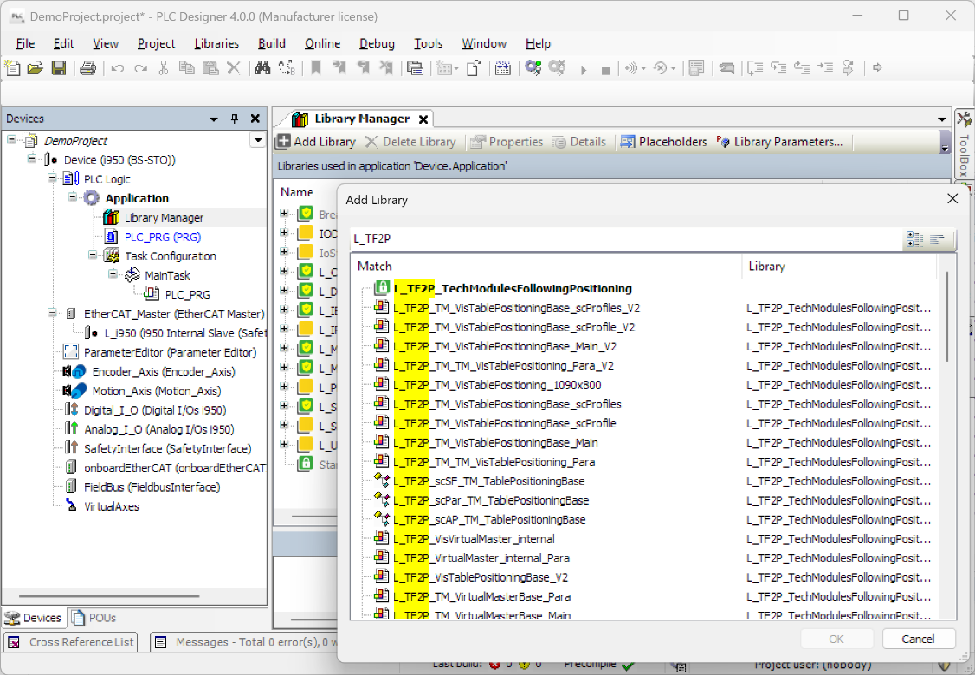
… and confirm by clicking Ok.
Mark the library L_TF2P_TechModulesFollowingPositioning …
When entering the first letters of the library name in the search window, you can easily find it in the selection list below.
Click on Add Library to browse the required library in the library repository.
Illustration 30: adding the L_TF2P_TechModulesFollowingPositioning library to your project

In the same way as shown in step 5, also include the L_TB2P_TechModulesBasic library in the Library Manager of your project.
Step 6

Open the PLC_PRG program and write a small CFC program as follows:
Step 7
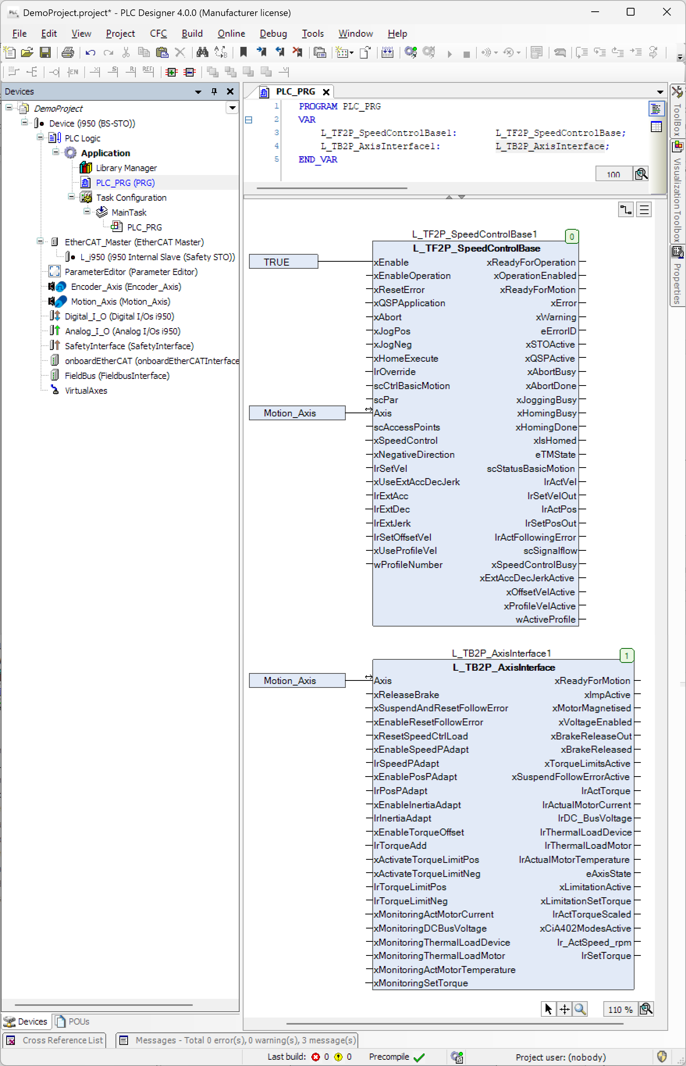
The function block L_TB2P_AxisInterface provides no additional functionality in the program. It is solely used to output important status information which the fieldbus interface requires when implementing it in a later stage (see chapter ‎3.2).
Then call the function block instance of L_TB2P_AxisInterface:
- Connect the i950 Motion_Axis to the Axis input of the function block.
Call the function block instance of L_TF2P_SpeedControlBase first:
- Continuously enable the function block by assigning a fixed TRUE signal to the xEnable input.
- Connect the i950 Motion_Axis to the Axis input of the technology function.
Declare instances of the function blocks L_TF2P_SpeedControlBase and L_TB2P_AxisInterface.
Double-click the PLC_PRG to edit it.
Illustration 31: calling the function blocks L_TF2P_SpeedControlBase1 and L_TB2P_AxisInterface1 in PLC_PRG

Insert an empty visualization panel:
Step 8
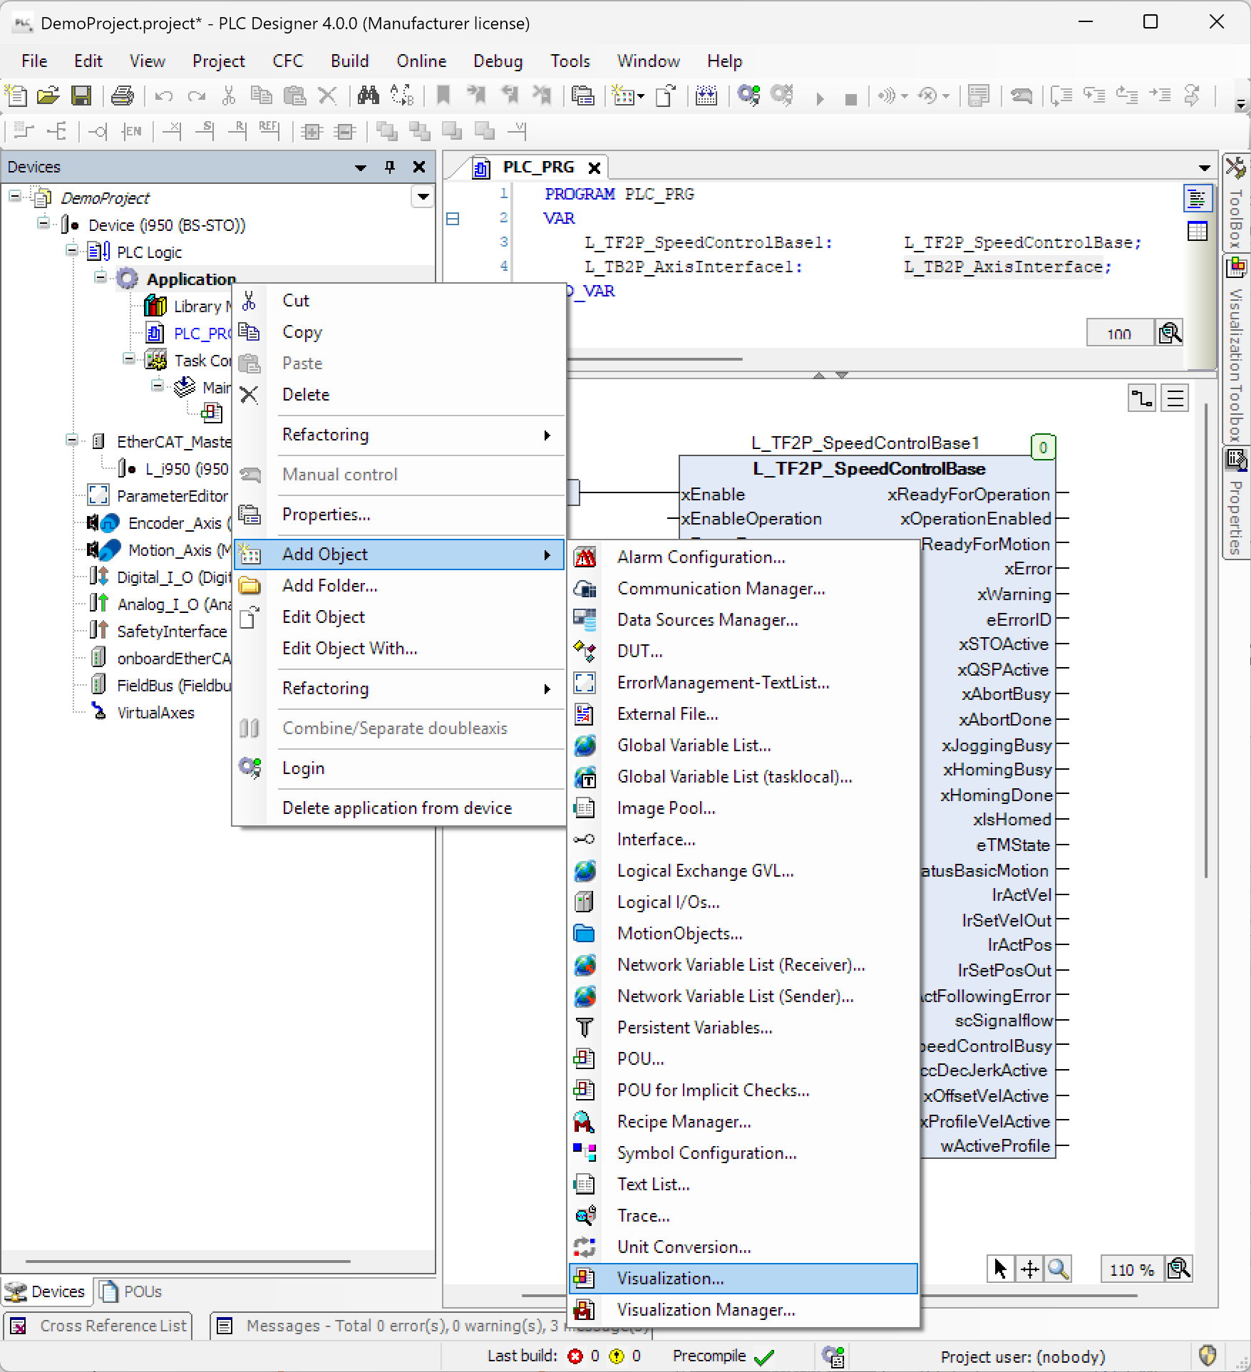
Pick a Visualization object and give it a unique name before adding it to your project
… and select Add Object.
Click right on Application to open the context menu …
Illustration 32: adding a visualization screen to operate the function block L_TF2P_SpeedControlBase

For a first test, insert the visualization template of the L_TF2P_SpeedControlBase technology module to operate it via the visu screen:
Step 9
Open the Visualization Toolbox.
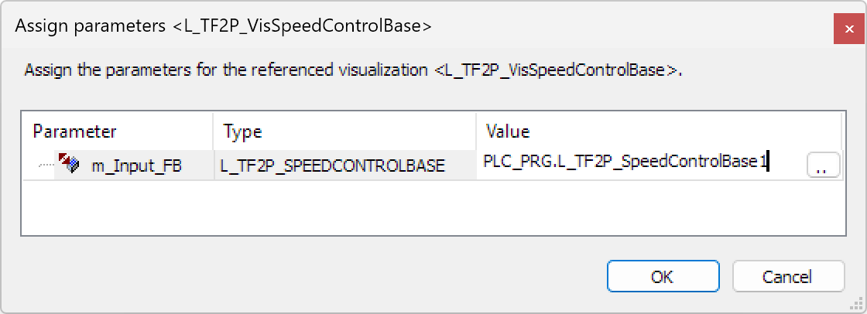
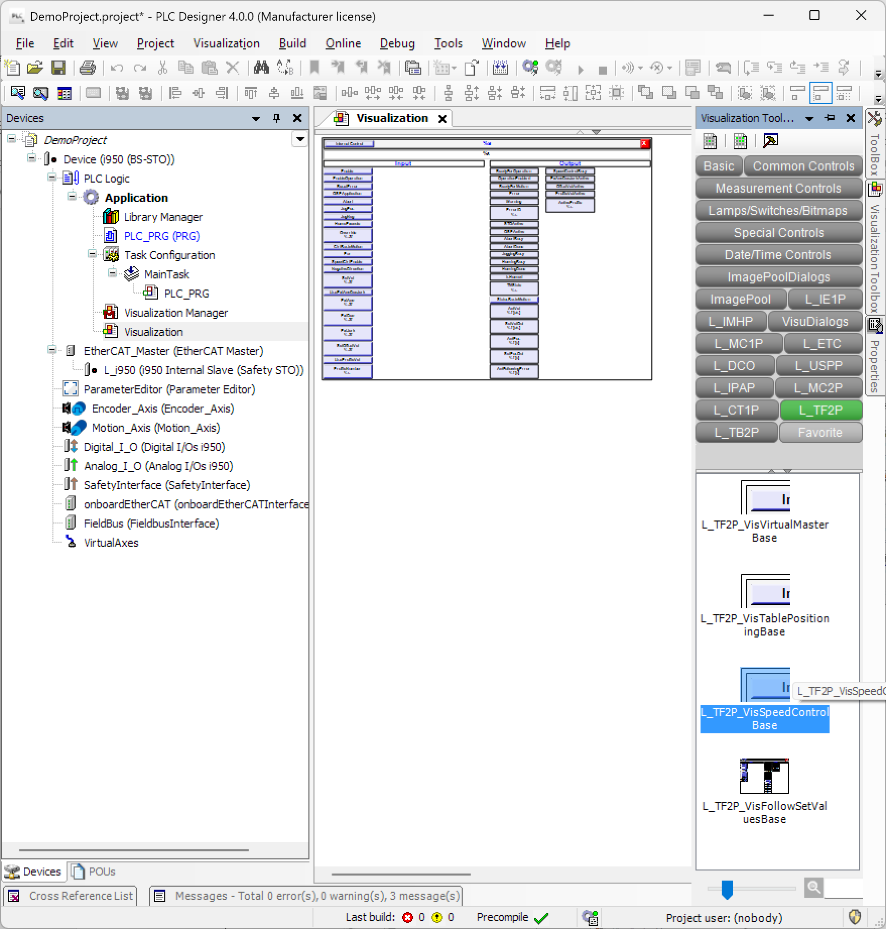
Drag the visualization template of L_TF2P_SpeedControlBase to the visualization screen and drop it at a convenient position on the new visualization screen.

Assign the function block instance L_TF2P_SpeedControlBase1 in the PLC_PRG program to the visualization template you just inserted.
Select the L_TF2P library.
Illustration 33: adding the visualization template of L_TF2P_SpeedControlBase

Step 10
Test your PLC program:
- Switch on mains power and 24V control power on your i950 drive.
- Download the project to your i950 drive controller and start the PLC program.
- Release the STO command on the i950 drive.

By means of the visualization screen, operate the i950 drive in different operation modes and check all functions:
Step 11

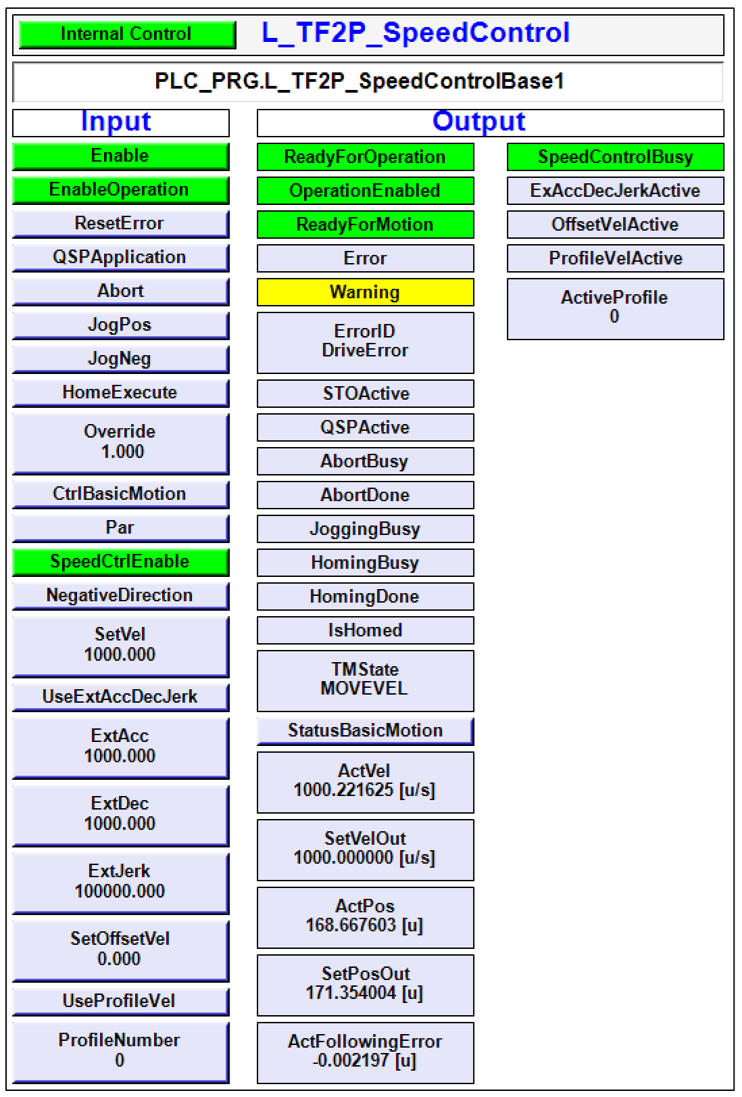
After enabling drive operation, you can run a first test by manual jogging the drive via the buttons JogPos and JogNeg.
Activate the internal control of the function block via the visualization screen.
Enable speed control mode by activating SpeedCtrlEnable.
Define a target speed in the input field SetVel. You now should see the drive rotating in positive direction.
If you like, you can adjust the acceleration, deceleration and jerk parameters as well.
Power-up the i950 drive by clicking on EnableOperation.
Illustration 34: visualization screen of L_TF2P_SpeedControlBase

end

Commissioning Sequence (PROFIBUS)
The following chapter describes how to set the PROFIBUS communication into operation with the help of the L_ICIP_CommunicationInterface function blocks.

Pre-Requisites:
Start
- The fieldbus system is wired according to the PROFIBUS specifications.
- The logic PLC (PROFIBUS master) as well as all PROFIBUS slave devices are supplied with control voltage (24V_{DC}).
- The PLC program of the i950 is open in »PLC Designer« but not yet online.
- The application signal flow has been implemented in the i950’s PLC program as described in the previous chapter ‎3.1, for example migrating motion applications of competitors or Lenze legacy devices.

Step 1
Open the Library Repository and install the L_ICIP_CommunicationInterface library:
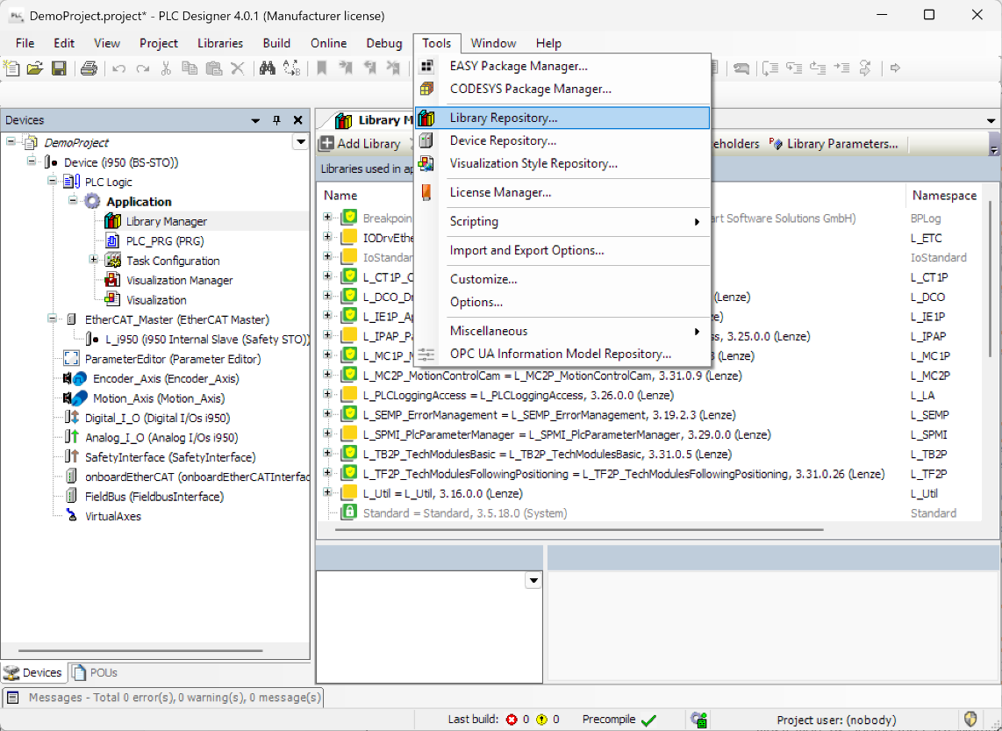
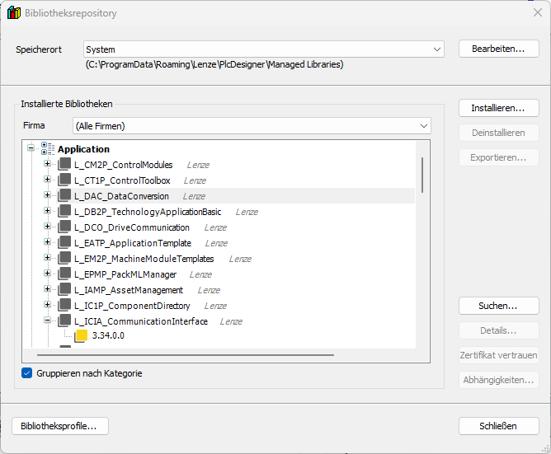
In the Tools menu …
Click Install to browse the L_ICIP_CommunicationInterface library from the library file attached to this AKB document.
… open the Library Repository.
After installing the L_ICIP_CommunicationInterface.library file, you should see it in the Application path of the Library Repository.
You can now close the Library Repository.

Illustration 35: adding the L_ICIP_CommunicationInterface library to the Library Repository

Step 2
Open the Library Manager to add the L_ICIP_CommunicationInterface library to your project:
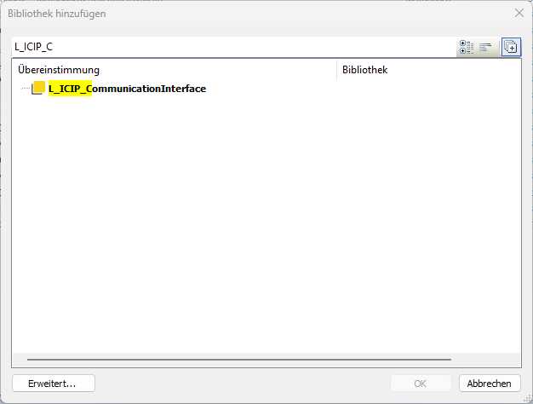
Double-click the Library Manager to open the list of included libraries.
Mark the library L_ICIP_CommunicationInterface …
Click on Add Library to browse the required library in the library repository.
When entering the first letters of the library name in the search window, you can easily find it in the selection list below.
… and confirm by clicking Ok.

Illustration 36: adding the L_ICIP_CommunicationInterface library to your project

In the same way as shown in step 2, also include the following libraries in the Library Manager of your project:
Step 3
- CAA Memory (V03.05)
- L_SI9P_IoDrvi900 (V03.33 – file attached to AKB document 202500431)

Note:
In the Library Manager, please resolve the placeholder for the L_SI9P_IoDrvi900 library and change it from a device-dependent version to a fixed version V03.33 or higher.

Tip:
To be sure to have the correct libraries in your project, you can open the project archive TM_SpeedControl.projectarchive attached to the AKB article 202500431.
Create your project on the base of this project archive.

Declare the following global interface variable arrays for fieldbus communication in a separate GVL item TA_IO:
Step 4
{attribute 'qualified_only'}
VAR_GLOBAL
adwPROFIBUS_IN: ARRAY [0..15] OF DWORD; // raw data input from PROFIBUS
adwPROFIBUS_OUT: ARRAY [0..15] OF DWORD; // raw data output to PROFIBUS
END_VAR

Map the variable arrays declared in step 4 to the fieldbus interface as follows:
Step 5
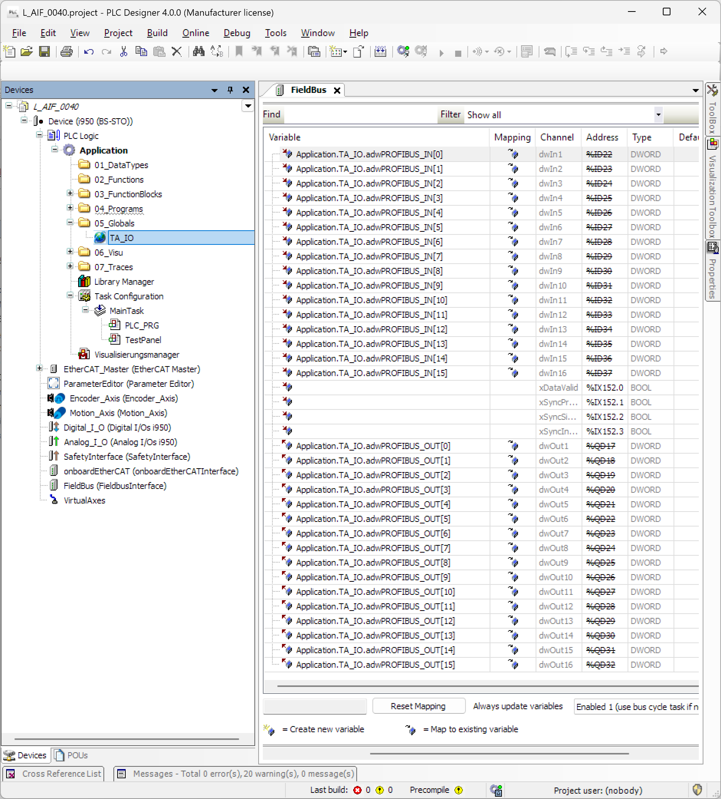
Map the output variable array TA_IO.adwPROFIBUS_OUT to the input channels of the fieldbus interface of i950.
Map the input variable array TA_IO.adwPROFIBUS_IN to the input channels of the fieldbus interface of i950.
Illustration 37: assignment of global variable arrays to the i950’s fieldbus interface

In the i950 motion program PLC_PRG, declare the following function blocks:
Step 6
VAR
L_ICIP_PROFIBUS_Base1:L_ICIP_PROFIBUS_Base; // handling of basic PROFIBUS communication
L_ICIP_PROFIBUS_In1: L_ICIP_PROFIBUS_In; // reading/processing fieldbus inputs to // scControlWords
L_ICIP_PROFIBUS_Out1: L_ICIP_PROFIBUS_Out; // processing/writing fieldbus outputs from // scStatusWords
L_STAT1: L_STAT; // generating the 4-bit pattern of the drive status
L_MC1A_ZeroDetect1: L_MC1A_ZeroDetect; // detection of rotation sense/zero speed
END_VAR

Prepare the parameter correspondence list by extending the declaration list in the i950’s motion program PLC_PRG:
Step 7
…
ascParReference: ARRAY [0..15] OF L_ICIP_sc93ParReference; // parameter reference list
…

NO
⇒ 10
?
Does your GSD configuration include a Drivecom V0 parameter channel?
YES

Extend the parameter correspondence list started in step 5 with the necessary initialization values as described in chapter ‎2.1.2:
Step 8
…
ascParReference: ARRAY [0..15] OF L_ICIP_sc93ParReference; // parameter reference list
(wCode:=51, bySubCode:=0, wIndex:=16#606C, bySubIndex:=0, bySize:=4, diNum:=1171875, diDen:=524288),
(wCode:=53, bySubCode:=0, wIndex:=16#6079, bySubIndex:=0, bySize:=4, diNum:=10, diDen:=1),
(wCode:=63, bySubCode:=0, wIndex:=16#2D49, bySubIndex:=5, bySize:=2, diNum:=1000, diDen:=1),
(wCode:=52, bySubCode:=0, wIndex:=16#2D82, bySubIndex:=0, bySize:=4, diNum:=10, diDen:=1),
(wCode:=54, bySubCode:=0, wIndex:=16#2DD1, bySubIndex:=5, bySize:=4, diNum:=10, diDen:=1),
(wCode:=61, bySubCode:=0, wIndex:=16#2D84, bySubIndex:=1, bySize:=2, diNum:=10, diDen:=1),
(wCode:=64, bySubCode:=0, wIndex:=16#2D40, bySubIndex:=7, bySize:=2, diNum:=1, diDen:=1),
…
(wCode:=84, bySubCode:=0, wIndex:=16#2C01, bySubIndex:=2, bySize:=4, diNum:=100, diDen:=1),
(wCode:=85, bySubCode:=0, wIndex:=16#2C01, bySubIndex:=3, bySize:=4, diNum:=10, diDen:=1)];
…

Step 9
First, call the function block L_ICIP_PROFIBUS_Base in your PLC program and connect the variables as shown:
As an axis reference, connect the i950 drive (Motion_Axis).
The variable structure ascParReference , which was declared in step 9, is assigned to the corresponding input ascParReference.

Illustration 38: call of function block L_ICIP_PROFIBUS_Base at the beginning of the PLC program

Call the function block L_ICIP_PROFIBUS_In directly after the function block L_ICIP_PROFIBUS_Base in your PLC program and connect the variables as shown:
Step 10
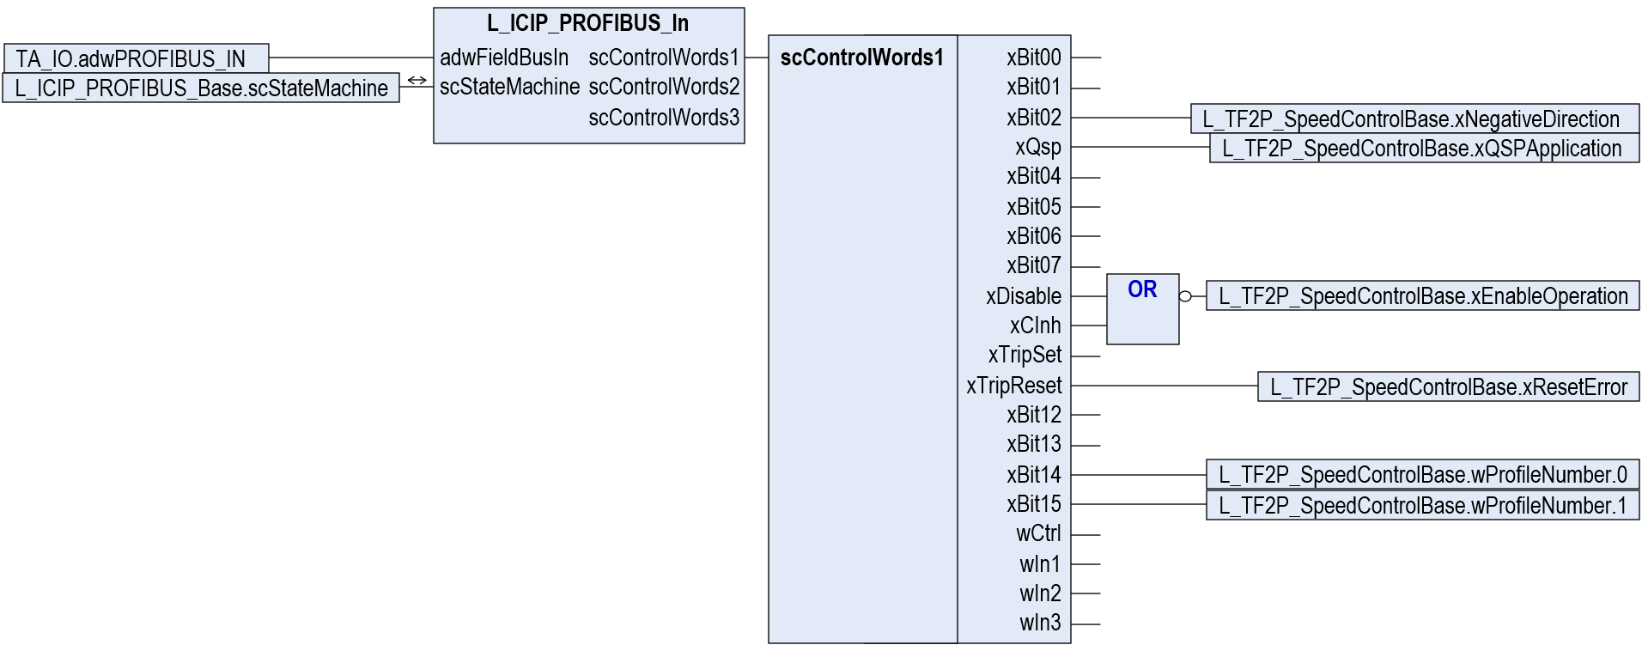
The function block L_ICIP_PROFIBUS_In reads the raw fieldbus data as declared in step 2.
L_ICIP_PROFIBUS_In interacts with L_ICIP_PROFIBUS_Base and L_ICIP_PROFIBUS_Out by sharing the variable structure L_ICIP_PROFIBUS_Base.scStateMachine.
Please connect it accordingly to ensure correct function!
To access each element of the process data of L_ICIP_PROFIBUS_In.scControlWords1, insert a selector of type scControlWords1.
Call the function block L_ICIP_PROFIBUS_In directly after the function block L_ICIP_PROFIBUS_Base in your PLC program.
Connect the xDisable and xCInh signals via an OR logic.
Do you see the signal negation at the OR output? Don’t forget to invert the OR output before assigning the output to L_TF2P_SpeedControlBase.xEnableOperation.
Connect the output of scControlWords1 to the technology module L_TF2P_SpeedControlBase.
Note:
On 9300, xBit00 and xBit01 were used to address fixed speeds. In this example, these bits are left disconnected.

Illustration 39: call of function block L_ICIP_PROFIBUS_In directly behind the function block L_ICIP_PROFIBUS_Base

Read the maximum speed value n_{max} from the legacy drives and convert it with the help of the drive axis’ kinematic parameters to a reference velocity V_{max}.
Step 11

Example: n_{max} = 3000[rpm]
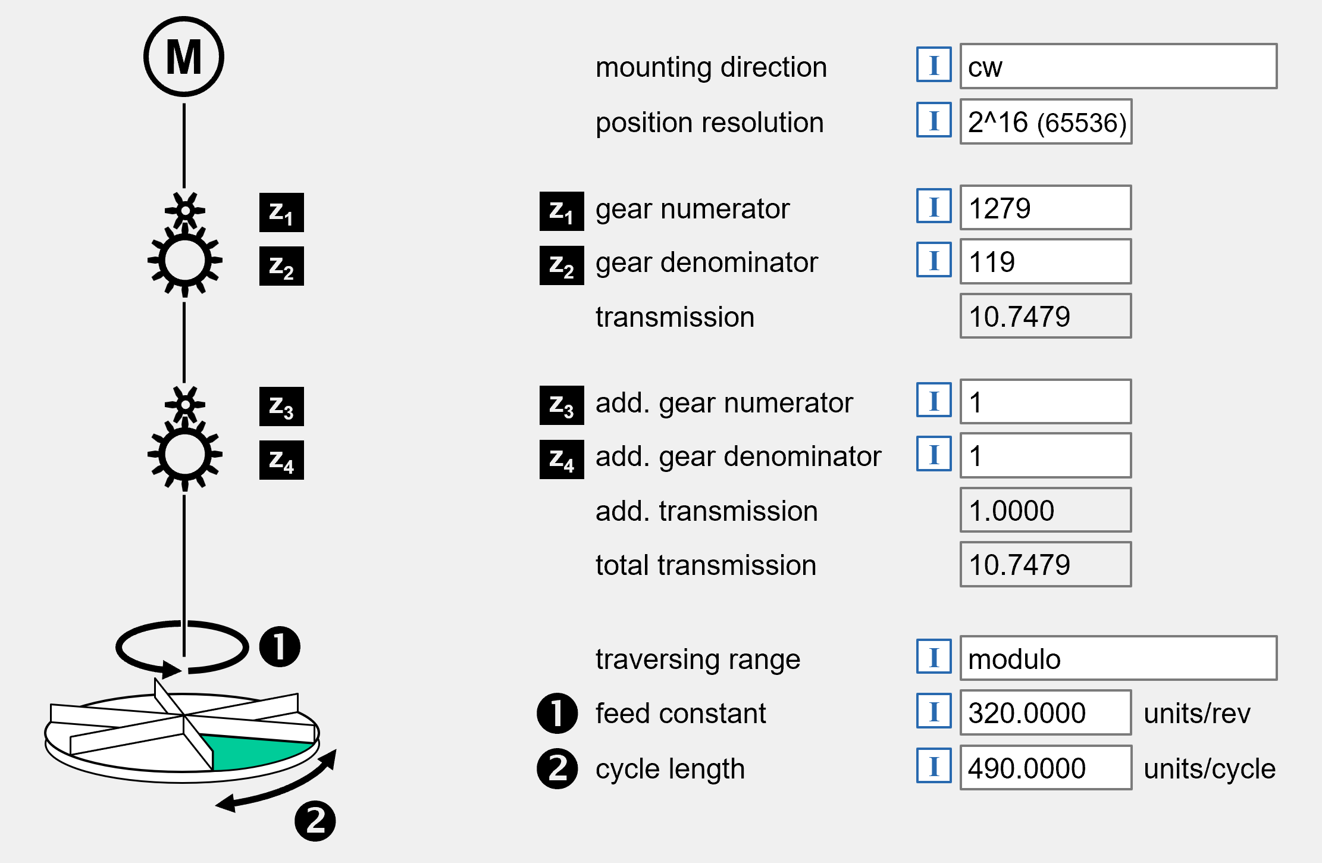

Illustration 40: kinematic parameters of the i950 drive

$$V_{max}=\frac{n_{max}}{60\frac{s}{min}}∙FeedConstant∙\frac{1}{i_{gear}}∙\frac{1}{i_{gear,add}}=$$

$$=\frac{n_{max}}{60\frac{s}{min}}∙0x500A:032∙\frac{0x500A:034}{0x500A:033}∙\frac{0x500A:026}{0x500A:025}=$$

$$=\frac{3000\frac{rev.}{min}}{60\frac{s}{min}}∙320.0000\frac{units}{rev.}∙\frac{119}{1279}∙\frac{1}{1}=1488.663…\frac{units}{s}$$

Step 12
Declare a constant variable C_lrMaxVelocity with an initialization value of V_{max} as calculated in the previous step:
VAR CONSTANT
C_lrMaxVelocity: LREAL := 1488.663; // maximum drive velocity, scaled in [units/s]
END_VAR

Read and scale the speed set value on L_ICIP_PROFIBUS_In.scControlWords1.wIn1, and route it via the following signal flow to the speed control technology module L_TF2P_SpeedControlBase. Modify your program as follows:
Step 13
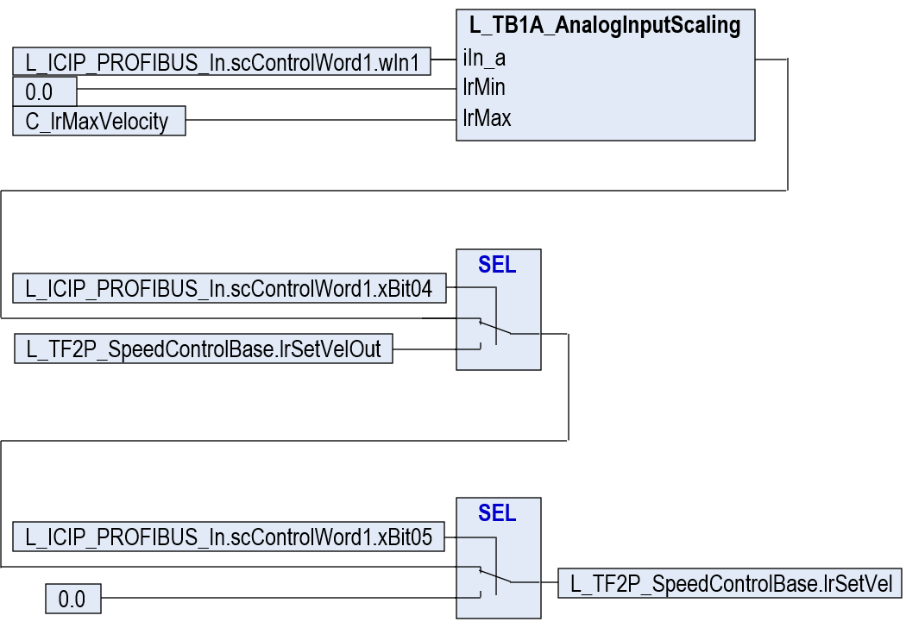

In the first step, the normalized input value on L_ICIP_PROFIBUS_In.scControlWord1.wIn1 with its value range is rescaled to a velocity range of 0.0 … C_lrMaxVelocity by means of the function L_TB1A_AnalogInputScaling.
The function L_TB1A_AnalogInputScaling is included in the export file loaded to the project in step 1. For more information to this function, please refer to the PDF document in AKB article 202000349.
The control bit L_ICIP_PROFIBUS_In.scControlWords1.xBit04 allows freezing the ramp function generator of the L_TF2P_SpeedControlBase technology module.
As currently this function is not included in the technology module itself, it must be programmed outside the technology module by means of a selector (SEL operator).
The control bit L_ICIP_PROFIBUS_In.scControlWords1.xBit05 switches the target velocity for the L_TF2P_SpeedControlBase technology module to a zero value. The function has priority over the ‘freeze’ function.
As currently this function is not included in the technology module itself, it must be programmed outside the technology module by means of a selector (SEL operator).
The selector’s output is assigned to the target velocity lrSetVel of the technology module L_TF2P_SpeedControlBase.

Illustration 41: reading/scaling/modifying the target velocity value lrSetVel of L_TF2P_SpeedControlBase

To prepare the status word on the L_ICIP_PROFIBUS_Out function block, three steps of preparation work is necessary:
Step 14
In the first step, declare a variable lrZeroSpeedThreshold for a velocity tolerance window. The tolerance window defines the behavior/stability of the zero-speed signal.
…
lrZeroSpeedThreshold: LREAL := 1.0; // zero-speed tolerance threshold, scaled in [units/s]
…

Initialize the variable with a velocity threshold limit value. Whenever the drive’s actual velocity is smaller/equal the threshold value, the (n=0) status flag goes to a TRUE level.

In the next step, call the function block L_MC1A_ZeroDetect at the end of your program and connect it in the signal flow as follows:
Step 15
Assign the following element variables of the Motion_Axis structure to the inputs of the L_MC1A_ZeroDetect function block:
- Motion_Axis.lrActPosition => L_MC1A_ZeroDetect.lrPosIn
- Motion_Axis.eTraversingRange => L_MC1A_ZeroDetect.eTraversingRange
- Motion_Axis.lrCycleLength => L_MC1A_ZeroDetect.lrCycleLength
Call the function block L_MC1A_ZeroDetect. The block is included in the export file loaded to the project in step 4. For more information to this function block, please refer to the PDF document in AKB article 202000349.

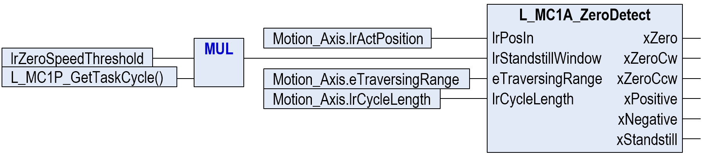
Multiply the zero-speed threshold limit (lrZeroSpeedThreshold) with the task cycle time Δt_{TaskCycle} (L_MC1A_GetTaskCycle()) to get a standstill hysteresis distance.
Connect the result to the input signal L_MC1A_ZeroDetect.lrStandstillWindow.

Illustration 42: zero speed detection by means of the function block L_MC1A_ZeroDetect

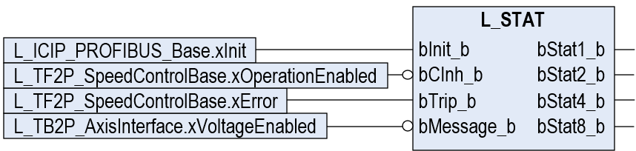
Call the function block L_STAT at the end of your program and connect the following variables:
Call the function block L_STAT at the end of your program.
The function block L_STAT is included in the export file loaded to the project in step 4.
Please consider the negations in the signal flow on the input signals L_STAT.bCInh_b and L_STAT.bMessage_b.
Step 16

Illustration 43: generation of status bits bStat1_b … bStat8_b by means of the function block L_STAT

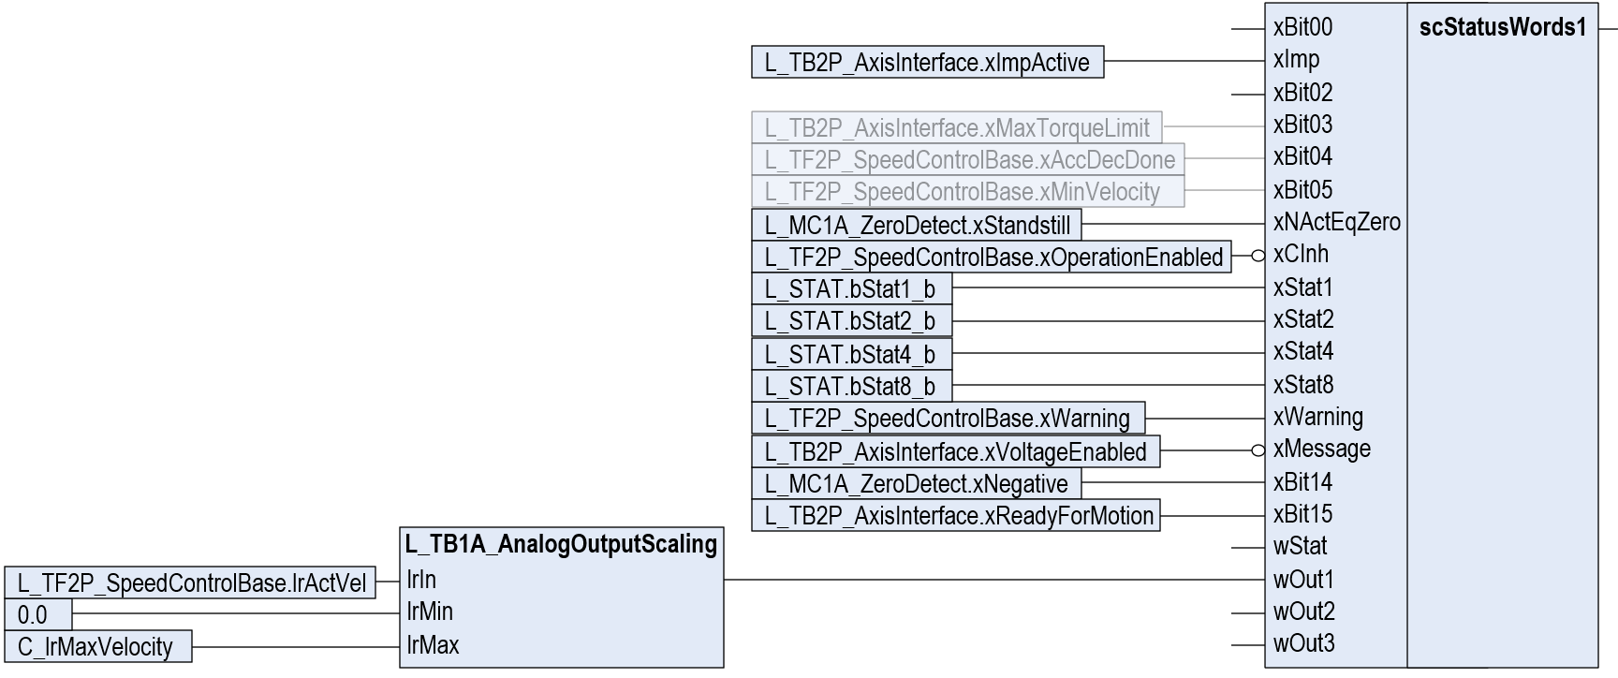
Insert a composer block of scStatusWords1 and connect the following signals:

Some (minor important) status signals are not yet available on the Lenze technology modules.
However, you may program work-arounds if you require these signals already.
The drive’s actual velocity (0.0 … C_lrMaxVelocity) is scaled to a normalized output signal (0 … 16384) on L_ICIP_PROFIBUS_Out.scStatusWords1.wOut1 by means of the function L_TB1A_AnalogOutputScaling.
The function L_TB1A_AnalogOutputScaling is included in the export file loaded to the project in step 4. For more information to this function, please refer to the PDF document in AKB article 202000349.
Step 17

Illustration 44: assignment of status signals/of normalized motor speed to the scStatusWords1 composer

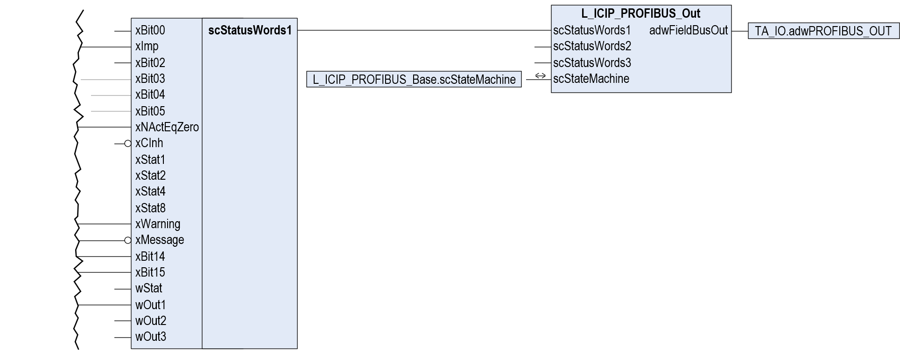
Insert the L_ICIP_PROFIBUS_Out function block at the end of your program, link the L_ICIP_scStatusWords1 composer’s output to the scStatusWords1 input of the L_ICIP_PROFIBUS_Out block and assign the generation of the AIF status word via function block L_ICIP_PROFIBUS_Out:
Insert the function block L_ICIP_PROFIBUS_Out.
Connect the scStatusWords1 composer’s output to the scStatusWords1 input of the L_ICIP_PROFIBUS_Out block.
L_ICIP_PROFIBUS_Out interacts with L_ICIP_PROFIBUS_Base and L_ICIP_PROFIBUS_In by sharing the variable structure L_ICIP_PROFIBUS_Base.scStateMachine.
Please connect it accordingly to ensure correct function!
.
Assign the adwFieldBusOut output array to the global variable array TA_IO.adwPROFIBUS_OUT already mapped to the fieldbus interface.
Step 18

Illustration 45: call of function block L_ICIP_PROFIBUS_Out at program end and assignment to the fieldbus output variables

Set the PROFIBUS station address of the i950 in index 0x2341:001:
Step 19
Index | SubIndex | Name | Value | Unit
0x2341 | 1 | PROFIBUS: Station address | 4

Make sure that index 0x2341:011 is set to a value of 1 (‘EMF2133IB (ID:2133)’) or of 2 (‘EMF2131IB (ID:2131)’).
Step 20
Index | SubIndex | Name | Value | Unit
0x2341 | 11 | PROFIBUS: Compatibility mode | EMF2133IB (ID: 0x2133) [1]

Compile, download and start the project to the i950 drive. You are now ready to control the i950 drive in the same way as the 9300 drive.
Step 21

end

Tip:
After downloading, restarting of the PROFIBUS slave might be necessary due to changed values in indexes 0x2341:001 and 0x2341:011.
Restart the PROFIBUS communication with the current settings with the following command:
no action / no error [0]

restart with default values [2]
stop communication [5]
in progress [10]
action cancelled [11]
fault [12]
restart with current values [1]
Index | SubIndex | Name | Value | Unit
0x2340 | 0 | PROFIBUS communication | restart with current values [1]

Appendix

Supported GSD Configurations
# | GSD configuration | PROFIBUS config value(s) | corresponding value in 0x2348:003
1. no parameter channel / process data (Drivecom control)
1 | PZD( 1W) | 0x70 | xx0170
… | … | … | …
12 | PZD(12W) | 0x7B | xx017B
2. consistent Drivecom parameter channel / process data (Drivecom control)
13 | PAR(cons.) + PZD( 1W) | 0xF3, 0x70 | xx02F370
… | … | … | ..
24 | PAR(cons.) + PZD(12W) | 0xF3, 0x7B | xx02F37B
3. consistent Drivecom parameter channel / consistent process data (Drivecom control)
25 | PAR(cons.) + PZD( 1W cons.) | 0xF3, 0xF0 | xx02F3F0
… | … | … | …
36 | PAR(cons.) + PZD(12W cons.) | 0xF3, 0xFB | xx02F3FB
4. Drivecom parameter channel / process data (Drivecom control)
37 | PAR + PZD( 1W) | 0x73, 0x70 | xx027370
… | … | … | …
48 | PAR + PZD(12W) | 0x73, 0x7B | xx02737B
5. Drivecom parameter channel / consistent process data (Drivecom control)
49 | PAR + PZD( 1W cons.) | 0x73, 0xF0 | xx0273F0
… | … | … | …
60 | PAR + PZD(12W cons.) | 0x73, 0xFB | xx0273FB
6. no parameter channel / consistent process data (Drivecom control)
61 | PZD( 1W cons.) | 0xF0 | xx01F0
… | … | … | …
72 | PZD(12W cons.) | 0xFB | xx01FB
7. no parameter channel / process data (Lenze device control)
73 | PZD( 1W) AR | 0x00, 0x00, 0x00, 0x70 | xx0400000070
… | … | … | …
84 | PZD(12W) AR | 0x00, 0x00, 0x00, 0x7B | xx040000007B
8. consistent Drivecom parameter channel / process data (Lenze device control)
85 | PAR(cons.) + PZD( 1W) AR | 0x00, 0x00, 0x00, 0xF3, 0x70 | xx05000000F370
… | … | … | …
96 | PAR(cons.) + PZD(12W) AR | 0x00, 0x00, 0x00, 0xF3, 0x7B | xx05000000F37B
9. consistent Drivecom parameter channel / consistent process data (Lenze device control)
97 | PAR(cons.) + PZD( 1W cons.) AR | 0x00, 0x00, 0x00, 0xF3, 0xF0 | xx05000000F3F0
… | … | … | …
108 | PAR(cons.) + PZD(12W cons.) AR | 0x00, 0x00, 0x00, 0xF3, 0xFB | xx05000000F3FB
10. Drivecom parameter channel / process data (Lenze device control)
109 | PAR + PZD( 1W) AR | 0x00, 0x00, 0x00, 0x73, 0x70 | xx050000007370
… | … | … | …
120 | PAR + PZD(12W) AR | 0x00, 0x00, 0x00, 0x73, 0x7B | xx05000000737B
11. Drivecom parameter channel / consistent process data (Lenze device control)
121 | PAR + PZD( 1W cons.) AR | 0x00, 0x00, 0x00, 0x73, 0xF0 | xx0500000073F0
… | … | … | …
132 | PAR + PZD(12W cons.) AR | 0x00, 0x00, 0x00, 0x73, 0xFB | xx0500000073FB
12. no parameter channel / consistent process data (Lenze device control)
133 | PZD( 1W cons.) AR | 0x00, 0x00, 0x00, 0xF0 | xx04000000F0
… | … | … | …
144 | PZD(12W cons.) AR | 0x00, 0x00, 0x00, 0xFB | xx04000000FB

AIF-IN Interface of 9300
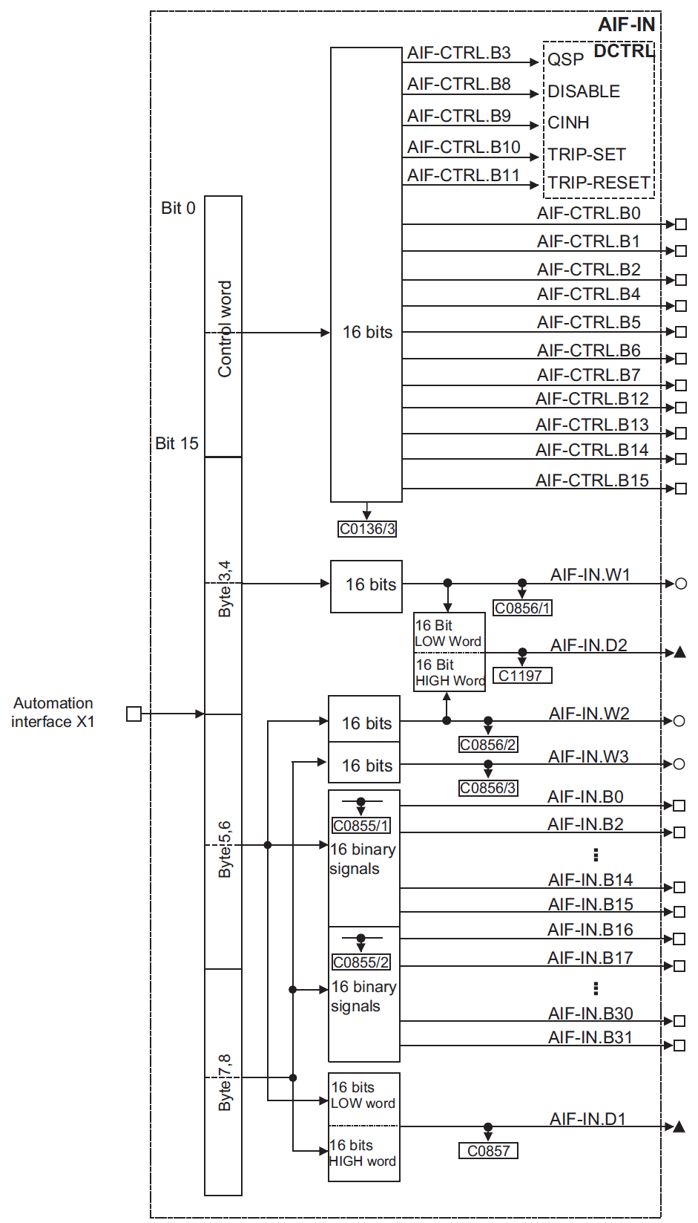

Illustration 46: signal flow of the AIF-IN interface on the 9300 servo inverter (excerpt from GDC help)

AIF-OUT Interface of 9300
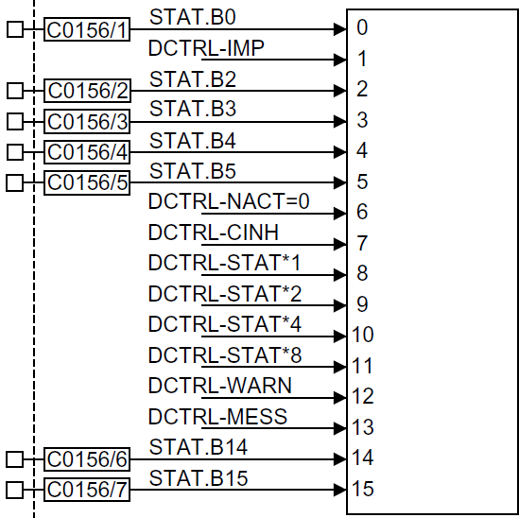

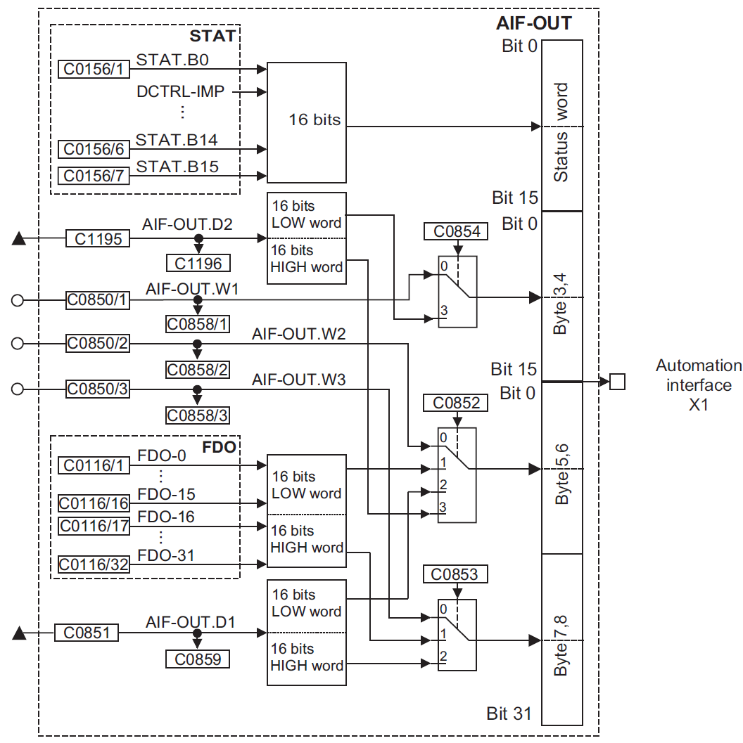

Illustration 47: signal flow of the AIF-OUT interface on the 9300 servo inverter (excerpt from GDC help)

Drivecom Control Word
Bit | Name | Meaning
0 | Switch On | command bit:
0 | Switch On |  | FALSE | commands 2, 6, 8 (controller inhibit)
0 | Switch On |  | TRUE | command 3 (controller enable)
1 | Voltage Inhibit | command bit: disable/enable motor voltage
1 | Voltage Inhibit |  | FALSE | inhibit voltage
1 | Voltage Inhibit |  | TRUE | enable voltage
2 | Quick Stop | command bit: activate quick stop
2 | Quick Stop |  | FALSE | activate quick stop
2 | Quick Stop |  | TRUE | release quick stop
3 | Enable Operation | command bit: enable drive operation
3 | Enable Operation |  | FALSE | disable drive operation
3 | Enable Operation |  | TRUE | enable drive operation
4 | RFG Inhibit | command bit: application quick stop (QSP)
4 | RFG Inhibit |  | FALSE | activate application quick stop (QSP)
4 | RFG Inhibit |  | TRUE | release application quick stop (QSP)
4 | RFG Inhibit | Note: The negated signal of this bit is directly output on scControlWords1.xQsp.
5 | RFG Stop | command bit: stop ramp function generator
5 | RFG Stop |  | FALSE | ramp function generator freezes  The drive maintains the actual speed even if the target speed on scControlWords1.iIn2 is not reached yet.
5 | RFG Stop |  | TRUE | ramp function generator is active  The drive accelerates/decelerates to the target speed on scControlWords1.iIn2.
5 | RFG Stop | Notes:  - The negated signal of this bit is directly output on scControlWords1.xBit04.  - In the basic application ‘SpeedControl’, bit 5 (RFG Stop) has minor priority against bit 6 (RFG Zero).
6 | RFG Zero | command bit: ramp down set speed to zero
6 | RFG Zero |  | FALSE | zero target speed  The drive ramps down to a zero speed. The value received on scControlWords1.iIn2 is ignored.
6 | RFG Zero |  | TRUE | external target speed  The drive follows the target speed on scControlWords1.iIn2.
6 | RFG Zero | Notes:  - The negated signal of this bit is directly output on scControlWords1.xBit05.  - In the basic application ‘SpeedControl’, bit 6 (RFG Zero) has priority over bit 5 (RFG Stop).
7 | Error Reset | command bit: reset drive error
7 | Error Reset |  | FALSE=>TRUE |  | resets a drive error
7 | Error Reset | Notes:  - A drive error can only be reset in case the error cause has been removed before.  - This bit is directly output on scControlWords1.xTripReset.
8 … 10 | (reserved)
11 | Manufacturer | free bit (directly output on scControlWords1.xBit07)
12 | Manufacturer | free bit (directly output on scControlWords1.xBit12)
13 | Manufacturer | free bit (directly output on scControlWords1.xBit13)
14 | Manufacturer | free bit (directly output on scControlWords1.xBit14)
15 | Manufacturer | free bit (directly output on scControlWords1.xBit15)

Drivecom Status Word
Bit | Name | Meaning
0 | Ready To Start | device state machine information:
0 | Ready To Start |  | FALSE | The device status is lower than Ready To Start.
0 | Ready To Start |  | TRUE | The device status is at least Ready To Start.
1 | Switched On | device state machine information:
1 | Switched On |  | FALSE | The device status is lower than Switched On.
1 | Switched On |  | TRUE | The device status is at least Switched On.
2 | Operation Enabled | device state machine information:
2 | Operation Enabled |  | FALSE | The device status is lower than Operation Enabled.
2 | Operation Enabled |  | TRUE | The device status is at least Operation Enabled.
3 | Fault | device is in error state:
3 | Fault |  | FALSE | no error is active on the device
3 | Fault |  | TRUE | an error is active on the device
3 | Fault | Note: The signal is derived from scStatusWords1.xStat8, scStatusWords1.xStat10 and scStatusWords1.xStat11.
4 | Voltage Inhibited | handshake signal: return of control bit 1 (“Voltage Inhibit“)
4 | Voltage Inhibited |  | FALSE | no error is active on the device
4 | Voltage Inhibited |  | TRUE | an error is active on the device
4 | Voltage Inhibited | Note: The signal is directly copied from bit 1 of the Drivecom control word (see previous chapter ‎4.4).
5 | Quick Stop | handshake signal: return of control bit 2 (Quick Stop)
5 | Quick Stop |  | FALSE | quick stop command is active on the device
5 | Quick Stop |  | TRUE | no quick stop command is active on the device
5 | Quick Stop | Note: The signal is directly copied from bit 2 or bit 4 of the Drivecom control word (see previous chapter ‎4.4).
6 | Switch-On Inhibited | device state machine information:
6 | Switch-On Inhibited |  | FALSE | The device is not in state Switch-On Inhibited.
6 | Switch-On Inhibited |  | TRUE | The device is in state Switch-On Inhibited.
7 | Warning | device is in warning state:
7 | Warning |  | FALSE | no warning is active on the device
7 | Warning |  | TRUE | a warning is active on the device
7 | Warning | Note: The signal of this bit is directly copied from scStatusWords1.xWarning.
8 | Message | message is active on the device:
8 | Message |  | FALSE | no message is active on the device
8 | Message |  | TRUE | a message is active on the device
8 | Message | Notes:  - A message state typically occurs in at an undervoltage state (main power switched off).  - The signal of this bit is directly copied from scStatusWords1.xMessage.
9 | Remote | fieldbus access authorization:
9 | Remote |  | FALSE | -
9 | Remote |  | TRUE | (this signal is set always TRUE in Drivecom operation mode)
10 | Set Point Reached | status of the internal ramp generator:
10 | Set Point Reached |  | FALSE | The actual drive speed does not match the target value.
10 | Set Point Reached |  | TRUE | The actual drive speed matches the target value.
10 | Set Point Reached | Notes:  - In default speed control, the signal represents the Set Point Reached status of the speed ramp generator. In this case, the following Drivecom command bits may suppress the Set Point Reached status signal:  - RFG Inhibit (command bit 4)  - RFG Stop (command bit 5)  - RFG Zero (command bit 6)  - Generally, the signal of this bit is directly copied from scStatusWords1.xBit04.
11 | Limit Value | Status of the Drivecom speed limitation (not supported):
11 | Limit Value |  | FALSE | (this signal is set always FALSE in Drivecom operation mode)
11 | Limit Value |  | TRUE | -
12 | Manufacturer | free bit (signal directly copied from scStatusWords1.xBit14)
13 | Manufacturer | free bit (signal directly copied from scStatusWords1.xBit03)
14 | Manufacturer | free bit (signal directly copied from scStatusWords1.xBit02)
15 | Manufacturer | free bit (signal directly copied from scStatusWords1.xBit05)

Drivecom DP V0 Parameter Channel (Tx)
The following chart describes the meaning of the transmit parameter channel request (8 bytes), sent by the PLC to the slave device (drive):

byte 1 (service) |  |  |  |  |  |  |  | byte 2 | byte 3 | byte 4 | bytes 5 … 8
7 | 6 | 5 | 4 | 3 | 2 | 1 | 0 | subindex | index  (high byte) | index  (low byte) | data

request type: 000 = no request
001 = read request (read data from device)
010 = write request (write data to device)
(not used)
data length: 00 = 1 byte
01 = 2 bytes
10 = 3 bytes
11 = 4 bytes
handshake:
- The PLC changes this (toggle) bit for every new request.
- The slave mirrors this bit into its response telegram (see chapter ‎4.7).

(not used – keep on FALSE level)

Illustration 48: structure of the Drivecom DP V0 parameter channel Tx telegram on the 9300 servo inverter (PLC => drive)

Drivecom DP V0 Parameter Channel (Rx)
The following chart describes the meaning of the receive parameter channel response (8 bytes), returned by the slave device (drive) to the PLC:

byte 1 (service) |  |  |  |  |  |  |  | byte 2 | byte 3 | byte 4 | bytes 5 … 8
7 | 6 | 5 | 4 | 3 | 2 | 1 | 0 | subindex | index  (high byte) | index  (low byte) | data / error code

mirror of the request type bits 0 … 2 (see chapter ‎2.1.4)
(not used)
data length: 00 = 1 byte
01 = 2 bytes
10 = 3 bytes
11 = 4 bytes
mirror of handshake bit 6 of the Tx telegram (see chapter 2.2.16):
- The PLC changes this (toggle) bit for every new request.
- The slave device copies the bit into its response telegram.

status bit:
Status information from the slave device to the PLC when sending the request confirmation. This bit informs the master PLC whether the request has been carried out without any faults.
0 = request completed without fault
(The data of bytes 5 ... 8 represent the data read from the target index.)
1 = request not completed - an error has occurred.
(The data of bytes 5 ... 8 represent the error number.)

The following error codes are returned in case of bit 7 is on TRUE:
byte 5 | byte 6 | byte 7 | byte 8 | error description
0x00 | 0x00 | 0x00 | 0x08 | no response to a request could be received within the watchdog time
0x00 | 0x00 | 0x03 | 0x06 | access not permitted for this parameter
0x00 | 0x00 | 0x07 | 0x06 | code number does not exist in the parameter reference list
0x00 | 0x00 | 0x08 | 0x06 | data types do not correspond
0x01 | 0xFE | 0x00 | 0x08 | invalid service (no read or write request)
0x10 | 0x00 | 0x05 | 0x06 | target index/sub-index number does not exist on the device
0x11 | 0x00 | 0x05 | 0x06 | sub-code number does not exist in the parameter reference list
0x12 | 0x00 | 0x05 | 0x06 | data length of the value to be written is too large
0x13 | 0x00 | 0x05 | 0x06 | data length of the value to be read is too small
0x30 | 0x00 | 0x00 | 0x08 | write access not denied due to drive operation enabled
0x31 | 0x00 | 0x00 | 0x08 | upper limit value of the parameter is not reached
0x32 | 0x00 | 0x00 | 0x08 | lower limit value of the parameter is not reached

Illustration 49: structure of the Drivecom DP V0 parameter channel Rx telegram on the 9300 servo inverter (drive => PLC)

For Lenze devices such as 9300, two AIF modules for PROFIBUS were available: 1 = EMF2133IB with an extended scope of GSD/GSE configurations (see chapter ‎4.1) 2 = EMF2131IB with a basic scope of GSD/GSE configurations (only Drivecom drive profile with 1 … 4 process data)
GDC = Global Drive Control, one of the most successful inverter/servo inverter series of Lenze
The FIX32 format uses a 4-byte data size and a scaling factor of 10000, meaning a value of 10000 represents a physical value of 1.0000[rpm]. This format is also known as the ‘_e4’ format in the Lenze terminology.
The ‘_s’ scaling was introduced with the Lenze 9400 series and scales the motor speed as a 32-bit value. A raw value of 2³¹ represents a physical value of 480000[rpm].
included the CAA Memory library
included the CAA Memory library
in particular the 9300 servo inverter series
basic configuration “speed control via AIF” (C0005/000 = 1003)
In this example, we use »PLC Designer« V4.x.
If no parameter channel is used, still the declaration is necessary as a dummy assignment.
scaled in [rpm]
In the Lenze legacy devices, the maximum speed was set in code C0011/000.
This setting defines which device type is reported via PROFIBUS to the logic PLC. A setting of 0x2341:11=1 makes the logic PLC believe that the connected device is a 8200/9300 with a PROFIBUS module EMF2133IB.
A setting of 0x2341:11=2 makes the logic PLC believe that the connected device is a 8200/9300 with a PROFIBUS module EMF2131IB.
no distinguishing between inconsistent/consistent data transmission
The 9300 index number results from subtracting the 9300 code number from a fixed value of 24575 (=0x5FFF).
length of data in bytes 5 ... 8 (data/error 1 ... 4) to be read/written to the slave device index
The 9300 index number results from subtracting the 9300 code number from a fixed value of 24575 (=0x5FFF).
length of the return data in bytes 5 ... 8 (data/error 1 ... 4)

