SMVector Application Example - Pumps
Temperature Controlling Pump (Cooling)
Description:
The inverter will automatically control the speed of the pump motor to maintain the desired temperature in the system. The user can set a desired temperature with the keypad (or potentiometer, or preset inputs). The inverter will compare the setpoint to the actual analog feedback signal coming from the temperature sensor and automatically adjust motor speed to achieve the setpoint temperature.
The inverter reaction to the analog feedback and the actual speed output value can be influenced greatly by the PID settings in the inverter
- The user must input the type of signal that will represent the setpoint (keypad, analog, preset)
- The user must input the type of signal that will represent the feedback (analog)
- The user must tune the P, I, and D gains for the actual system

Example:
A pump supplies cooling water to a process to maintain a given temperature to a process. In this application an increase in cooling water causes a decrease in the measured temperature. Put more simply, the more heat is added to the system, the more cooling water the pump must supply to maintain temperature. The pump is controlled by an inverter.
The temperature sensor converts 0-100 degrees Celsius to a 4-20mA signal which is wired directly to the inverter.
A master RUN/STOP switch (2 wire contact) is wired to the drive to run/stop the drive.
Setpoint is entered via the keypad as 50% (for 50 degrees Celsius).
An alarm is to be actuated if the feedback rises above 80% (for 80 degrees C).
The drive will achieve energy savings by following the variable (quadratic) V/Hz profile to leverage the inherent energy savings of the power requirements of the Affinity Laws in relation to centrifugal pumps.
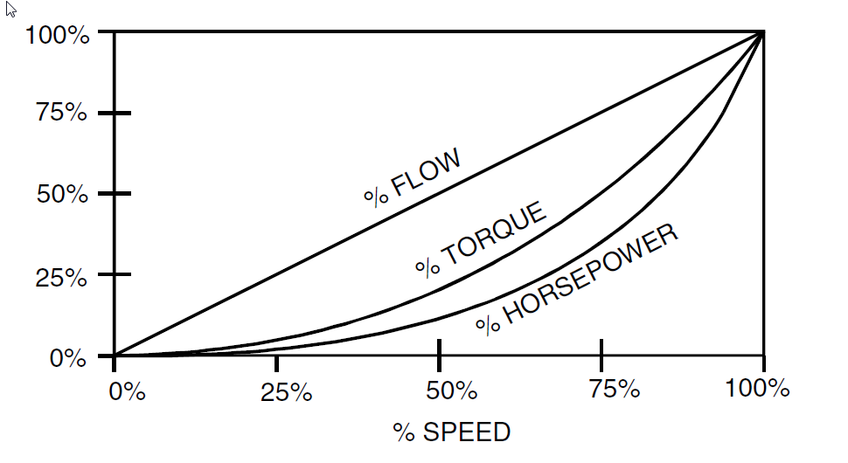

Installation:
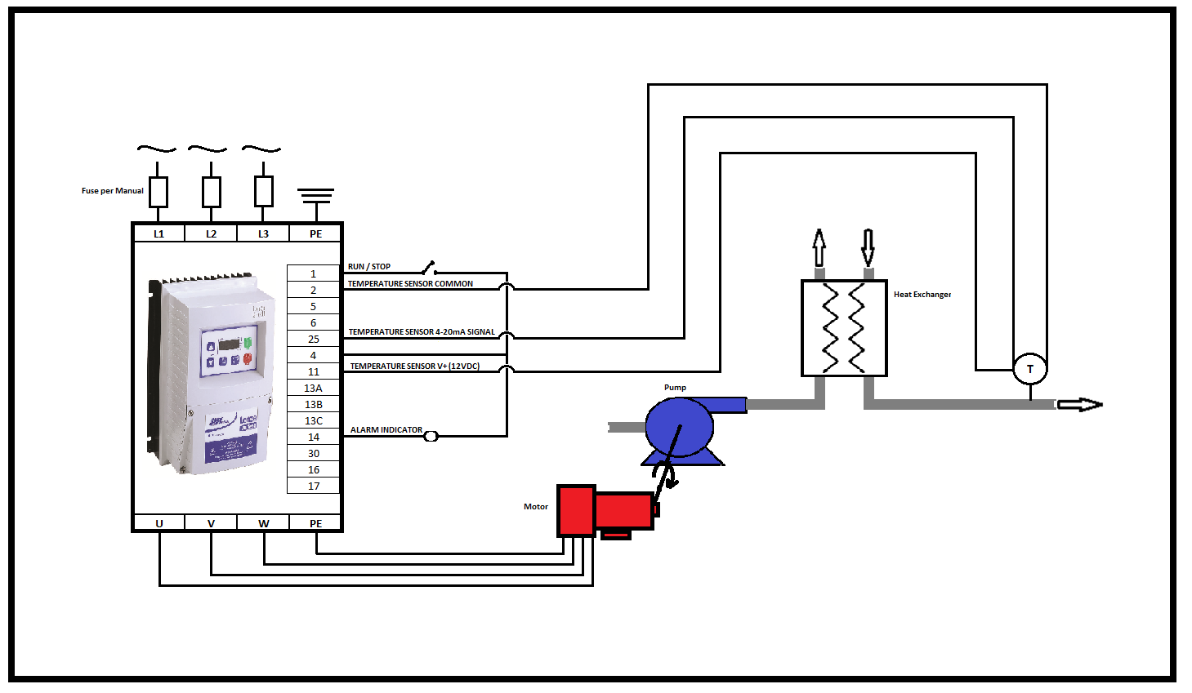

Equipment in this example:
- SMVector drive
- Motor/pump
- Temperature sensor
- Maintained run/stop contact

Relevant parameters and settings:
- P100 – Start Control Source = 1 (Terminal Strip)
- P101 – Standard Reference Source = 3 (Preset #1 [P131])
- P102 – Minimum Frequency = 10.0 Hz
- P103 – Maximum Frequency = 60.0 Hz
- P104 – Acceleration Time 1 = 2.0 seconds
- P105 – Deceleration Time 1 = 2.0 seconds
- P108 – Motor Overload (P108 = motor current rating [A] x 100/ SMV output rating[A])
- P110 – Start Method = 0 (Normal)
- P111 – Stop Method = 0 (Coast)
- P121 – TB13A Digital Input = 11 (Start Forward)
- P123 – TB13C Digital Input = 6 (Auto Reference: Keypad)
- P131 – Preset Speed #1 = 60.0 Hz
- P156 – Analog Inputs Configuration = 0 (TB5: [0-10VDC], TB25: [4-20mA])
- P200 – PID Mode = 1 (Normal Acting)
- P201 – PID Feedback Source = 1 (0-10VDC [TB5])
- P202 – PID Decimal Point = 1 (XXX.X)
- P203 – PID Units = 1 (/Units)** Applies to 15HP and Larger SMV Drives ONLY**
- P204 – Feedback at Minimum Signal = 0.0 (to match the Pressure Transducer)
- P205 – Feedback at Maximum Signal = 80.0 (to match the Pressure Transducer)
- P207 – PID P Gain (Must Be Tuned For System)
- P208 – PID I Gain (Must Be Tuned For System)
- P209 – PID Derivative Gain (Must Be Tuned For System)
- P240 – Sleep Threshold = 20.0Hz
- P241 – Sleep Delay = 10.0 Seconds
- P242 – Sleep Bandwidth = 0.0
- P244 – Sleep Entry Mode = 0 (Enter Sleep if Drive Speed < P240)
- P245 – Sleep Entry Stop Type = 0 (Coast to Stop)
- P246 – Feedback Recovery from Sleep Threshold = 32.0
- P247 – Sleep Recovery Mode = 1 (Recover only if Feedback < P246)
- P300 – Drive Mode = 1 (Variable V/Hz)
PID Gains need to be tuned for the system at hand to get this application to run. See NOTE-PID Tuning for details.

Chart example showing reaction of drive output frequency to I/O:
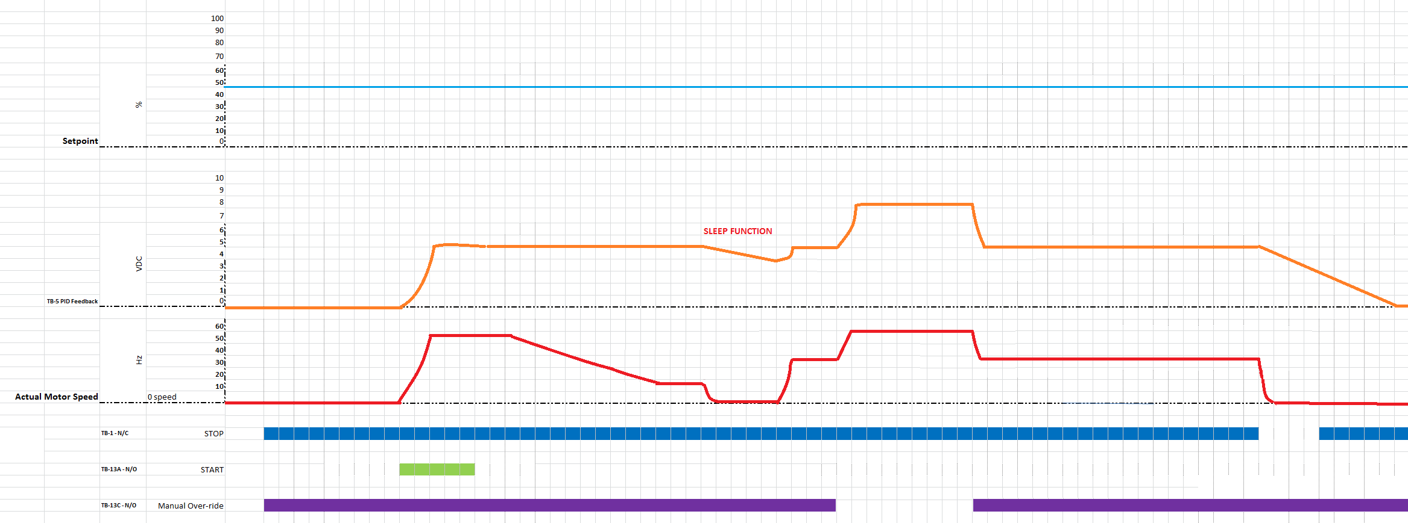

Special Notes- PID Tuning:
The Ziegler–Nichols tuning method is a common method of tuning a PID Loop. It is performed by first setting the Ki (integral) and Kd (derivative) gains to zero. The Kp (proportional) gain is then increased (from zero) until it reaches the point at which the output of the control loop oscillates with a constant amplitude. This point is the Ku (ultimate) gain. At this point the Tu (oscillation period) is used in conjunction with the Ku to calculate the appropriate gain settings:

Control Type | Kp | Ki | Kd
P | 0.500 * Ku | - | -
PI | 0.454 * Ku | 0.833 * Tu | -
PID | 0.600 * Ku | 0.500 * Tu | 0.125 * Tu
Some Overshoot | 0.333 * Ku | 0.500 * Tu | 0.333 * Tu
No Overshoot | 0.200 * Ku | 0.500 * Tu | 0.333 * Tu

