SMVector Application Example - Pumps
Pressure Controlling Pump
Description:
The inverter will automatically control the speed of the pump motor to maintain the desired pressure in the system. The user can set a desired pressure with the keypad. The inverter will compare the setpoint to the actual analog feedback signal coming from the pressure sensor and automatically adjust motor speed to achieve the setpoint pressure.
The inverter reaction to the analog feedback and the actual speed output value can be influenced greatly by the PID settings in the inverter
- The user must input the type of signal that will represent the setpoint (keypad, analog, preset).
- The user must input the type of signal that will represent the feedback (analog).
- The user must tune the P, I, and D gains for the actual system.

Example:
Pressure is needed to be maintained over various flow rates by a given pump. In this application an increase in the speed of the pump causes an increase in the pressure of the driven fluid. The pump is controlled by an inverter with the setpoint being entered by the keypad. Pressure in the system is sensed by a pressure transducer which translates 0-80PSIG to 0-10VDC. The transducer is wired directly to the inverter.
A momentary normally open pushbutton is used to start the drive and a normally closed momentary pushbutton is used to stop the drive.
The desired setpoint is 40.0 PSIG, The SMVector can be programmed to solve PID in user units so the keypad is set to 40.0.
In this application there are certain times of day where there is no actual usage of the fluid. At these times it is desired that the pump go into a sleep mode to conserve energy and that it wake once usage resumes. We will define that point as when the pump only requires 20Hz output frequency or less to maintain the desired setpoint. We will wait for this condition to be present for 10 seconds prior to entering sleep mode. We will exit sleep mode when pressure falls to 32 PSIG.
The system also has a manual over-ride mode. When this mode is selected the system will come out of PID mode and run at a preset speed of 60.0Hz. The function of this input in the SMVector drive is such that when the input is asserted, the drive is in PID mode. When the input is not asserted, the drive will drop out of PID Mode.
The drive will achieve energy savings by following the variable (quadratic) V/Hz profile to leverage the inherent energy savings of the power requirements of the Affinity Laws in relation to centrifugal pumps.
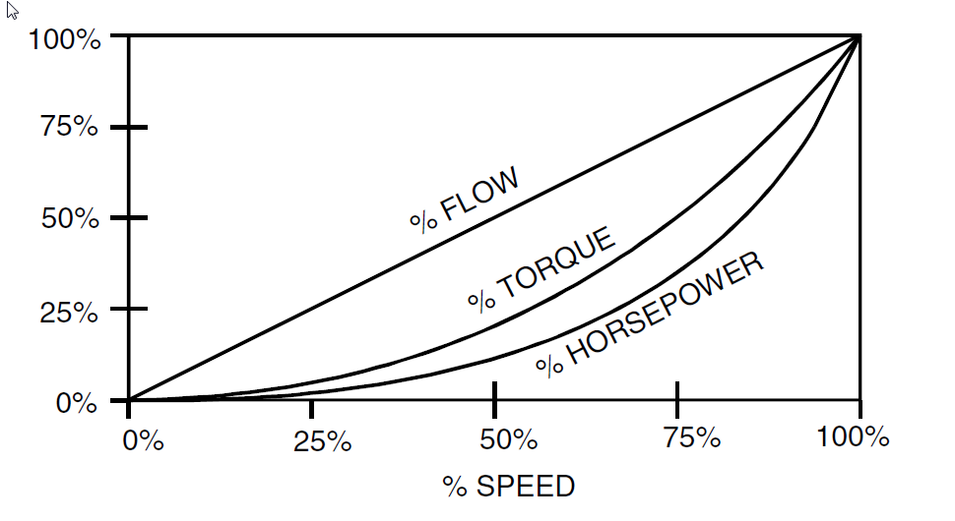

Installation:
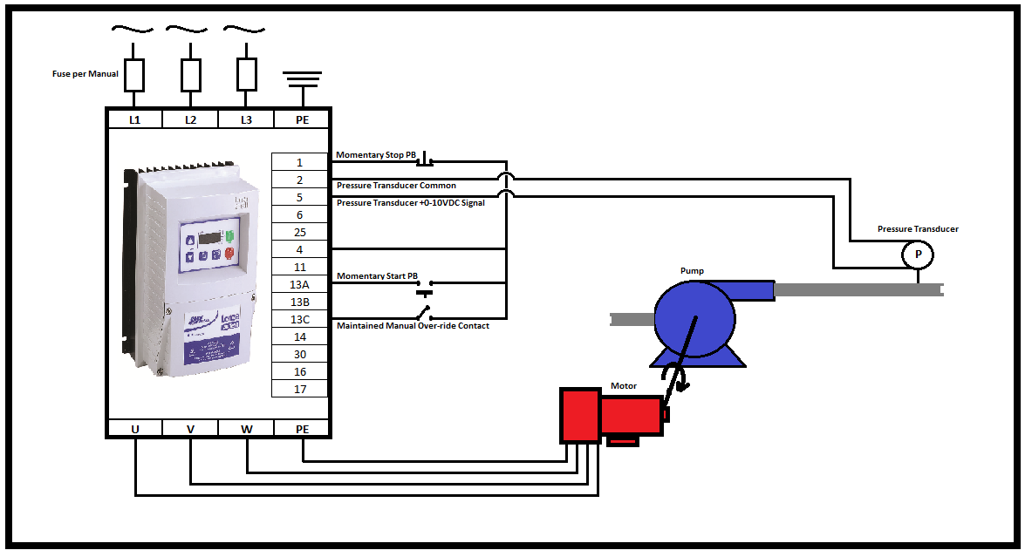

Equipment in this example:
- SMVector drive
- Motor/pump
- 0-10VDC Pressure transducer
- N/C momentary stop button
- N/O momentary start button
- Maintained “manual over-ride” contact (when asserted the drive is in PID mode, when not asserted the drive will run at Preset Speed 1)

Relevant parameters and settings:
- P100 – Start Control Source = 1 (Terminal Strip)
- P101 – Standard Reference Source = 3 (Preset #1 [P131])
- P102 – Minimum Frequency = 10.0 Hz
- P103 – Maximum Frequency = 60.0 Hz
- P104 – Acceleration Time 1 = 2.0 seconds
- P105 – Deceleration Time 1 = 2.0 seconds
- P108 – Motor Overload (P108 = motor current rating [A] x 100/ SMV output rating[A])
- P110 – Start Method = 0 (Normal)
- P111 – Stop Method = 0 (Coast)
- P121 – TB13A Digital Input = 11 (Start Forward)
- P123 – TB13C Digital Input = 6 (Auto Reference: Keypad)
- P131 – Preset Speed #1 = 60.0 Hz
- P156 – Analog Inputs Configuration = 0 (TB5: [0-10VDC], TB25: [4-20mA])
- P200 – PID Mode = 1 (Normal Acting)
- P201 – PID Feedback Source = 1 (0-10VDC [TB5])
- P202 – PID Decimal Point = 1 (XXX.X)
- P203 – PID Units = 1 (/Units)** Applies to 15HP and Larger SMV Drives ONLY**
- P204 – Feedback at Minimum Signal = 0.0 (to match the Pressure Transducer)
- P205 – Feedback at Maximum Signal = 80.0 (to match the Pressure Transducer)
- P207 – PID P Gain (Must Be Tuned For System)
- P208 – PID I Gain (Must Be Tuned For System)
- P209 – PID Derivative Gain (Must Be Tuned For System)
- P240 – Sleep Threshold = 20.0Hz
- P241 – Sleep Delay = 10.0 Seconds
- P242 – Sleep Bandwidth = 0.0
- P244 – Sleep Entry Mode = 0 (Enter Sleep if Drive Speed < P240)
- P245 – Sleep Entry Stop Type = 0 (Coast to Stop)
- P246 – Feedback Recovery from Sleep Threshold = 32.0
- P247 – Sleep Recovery Mode = 1 (Recover only if Feedback < P246)
- P300 – Drive Mode = 1 (Variable V/Hz)
PID Gains need to be tuned for the system at hand to get this application to run. See NOTE-PID Tuning for details.

Chart example showing reaction of drive output frequency to I/O:
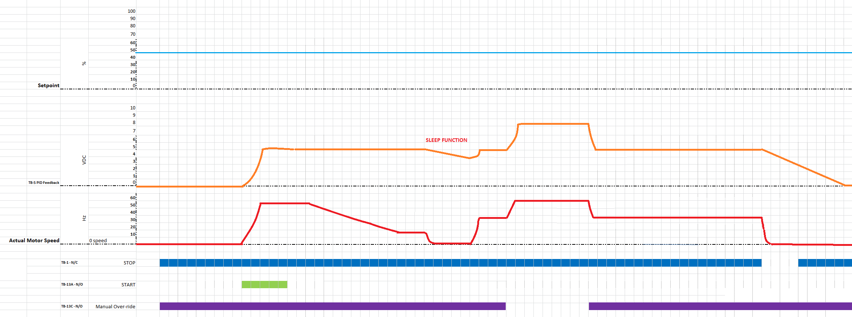

Special Notes- PID Tuning:
The Ziegler–Nichols tuning method is a common method of tuning a PID Loop. It is performed by first setting the Ki (integral) and Kd (derivative) gains to zero. The Kp (proportional) gain is then increased (from zero) until it reaches the point at which the output of the control loop oscillates with a constant amplitude. This point is the Ku (ultimate) gain. At this point the Tu (oscillation period) is used in conjunction with the Ku to calculate the appropriate gain settings:

Control Type | Kp | Ki | Kd
P | 0.500 * Ku | - | -
PI | 0.454 * Ku | 0.833 * Tu | -
PID | 0.600 * Ku | 0.500 * Tu | 0.125 * Tu
Some Overshoot | 0.333 * Ku | 0.500 * Tu | 0.333 * Tu
No Overshoot | 0.200 * Ku | 0.500 * Tu | 0.333 * Tu

